



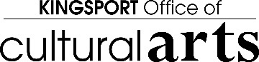

CALL FOR QUALIFICATIONS FOR KINGSPORT, TN

ROTARY CLUB SCULPTURE AT BRICKYARD PARK

The Rotary Club of Kingsport, TN, in collaboration with the Kingsport Public Art Committee, Edens Investment, and Barge Design Solutions, Inc., is seeking qualifications from artists or art teams for the commission of a centennial sculpture to commemorate the every-day heroes of the community at the traffic circle currently in development for the Brickyard Village.

ELIGIBILITY: This opportunity is open to all professional artists over the age of 18 with previous public sculpture experience. Refer to the Selection Criteria listed below for additional requirements.

BUDGET: Up to three finalists will be selected to develop concept proposals for this project. The total project budget for the selected commission is not to exceed

$50,000. Each finalist will be paid a $500 stipend for his/her proposal. The selected artist/art team will be paid up to $48,500 for the commissioned work. The selected artist/art team will be responsible for own travel costs, materials, housing, and personal liability insurance. Finalists will be required to present their work to the Selection Committee and will not be reimbursed for travel costs or hotel accommodations. If a finalist prefers to present their concept proposal virtually, then arrangements will be made to do so.

DEADLINE: August 8, 2022

QUESTIONS: Deborah Mullins [debjdaugherty@gmail.com](mailto:ckumbhare@johnsoncitytn.org)

# KINGSPORT:

**Nestled among the mountains, and within 8 hours of multiple large cities like Atlanta, Georgia and Washington D.C., Kingsport is a growing community.**

**Kingsport has a strong and proud industrial heritage spanning over 100 years. As we look to the future, we are diversifying our industrial roots with progressive technological innovations.** **Kingsport is the home of Eastman Chemical and Domtar. The most appealing parts of Kingsport are the outdoor recreation opportunities like Bays Mountain Park, the Greenbelt, and the Kingsport Aquatic Center. The Kingsport Axmen is the local Minor League baseball team for which we cheer, and every July the whole community celebrates Fun Fest—over 100 events in 60 locations over the course of 9 days.**

**Kingsport’s community sets it apart. From established neighborhoods to downtown living, quality opportunities for professional growth and people who care, anyone can find their niche. We do not shy away from innovation. Partnerships are what make Kingsport work. Our partnerships are a testament to our sustained growth. We are a region of hard workers.**

**Internationally recognized as a Safe Community by Safe Communities America, Kingsport is one of only 19 International Safe Communities across the nation and the only city with the distinction in Tennessee.**

**Kingsport has invested $92 million in infrastructure and quality of life projects in the last five years. The City of Kingsport provides economic, educational and quality of life opportunities that create a safe, vibrant and diverse community. The Office of Cultural Arts, a department of the City of Kingsport, connects, coordinates and engages the public with a creative community. They manage cultural spaces including events at the Renaissance Center, Farmers Market, and Carousel facilities. They provide administrative support to Kingsport Public Art programs, stimulate community engagement and economic development through the Arts, and present arts and crafts festivals such as The Christmas Connection and #Madeinkingsport.**

**Kingsport, Tennessee is a charming town filled with community spirit and growth.**

# BRICKYARD DEVELOPMENT:

# The Brickyard Development includes a variety of recreation facilities alongside a new residential development called Brickyard Village. Brickyard Park is a 43-acre premier sports facility and community park, including 4 fenced and lighted ball fields with electric scoreboards and bleachers and a central concession building with a second story scorers’ area. Adjacent to the 4-plex, is a Miracle Field complex including an adaptive baseball field, central restroom/concession building, covered picnic area, covered stadium seating area, and a Blue Cross Blue Shield Healthy Place universally accessible playground.

# Across from the ballfield complex is the new Scott Adams Memorial Skate Park, which will open this month. This facility includes a 13,000 square foot skate park, restroom building, plaza area and parking lot. The second phase of development is currently in design and will include a pump track facility along with expanded parking and plaza spaces. Additional future amenities will include a bike skills area with additional bike trails and obstacles.

# Adjacent to the recreational areas, a new residential development, Brickyard Village, will include over 380 rental and for-sale units with a combination of apartments, duplexes, townhomes and single family homes. The overall design of the community includes additional recreational opportunities and amenities including a Community Building and swimming pool, playground, community garden area, basketball and pickle ball courts, picnic, grill, and fire pit areas, dog park, perimeter walking trail, and additional park/open green space. A large open area is also designated as a venue space to allow for festivals or concerts.

# PROJECT DESCRIPTION:

As part of the Brickyard Village development, the new road system will include a traffic circle central to the right-of-way and directly adjacent to the Community Building. The Brickyard sculpture will be commissioned by the Rotary Club of Kingsport and installed in the traffic circle under coordination with the City of Kingsport’s Office of Cultural Arts. An elevated platform for the sculpture will be constructed in the center of the traffic circle. The design of this platform will include a cog design, representing both the Rotary logo and the original City seal.

The sculpture must not exceed the 33.5 ft. platform, but the artist(s) is encouraged to use multiple components to fill the space as needed and frame the views of the Community Building. The sculpture must be lit at night or have light elements incorporated into the design. Careful consideration should be given to the lighting, such that it does not create glare that would negatively affect motorists or residences fronting the traffic circle.

The sculpture should be highly visible 24 hours per day, both day and night, and should activate the space that it occupies. The use of moving parts should be limited. The sculpture should not have any fragile components and should be resistant to vandalism. It should be a substantial, durable and long- lasting piece. It is intended to be one of the main attractions within the Village, engaging viewers.

**The Rotary Club of Kingsport would like to sponsor a commemorative sculpture in honor of their Centennial year. “Everyday Heroes” should reflect the Kingsport Spirit and Rotary’s motto, “Service Above Self”:**

**Kingsport is a tale of two cities built 100 years apart along the Holston River at Long Island – one of the most important historic sites in Cherokee history. Indian lands were converted into farms, forged by the labor of African-Americans. The original ‘port’ along the river dissipated after the Civil War. Post-war industrialists built a new city, which assumed the same name, eventually incorporating the old town site. The original industries included brick, cement, and lumber – the basic materials required to build “the first thoroughly diversified, professionally planned, and privately financed city in twentieth-century America.”   J. Fred Johnson was affectionately called “The Father of Kingsport.” He was also a founding member of Rotary Club of Kingsport.   He coined the term, “Kingsport Spirit” as “one of mutual helpfulness and a willingness to submerge selfish interests beneath the individual effort to assure the greater good for the greater number.”**

**Brickyard Park -- where Cherokee Street, Martin Luther King, Jr. Drive, and Brickyard Park Drive converge – represents the unique convergence of all periods of Kingsport’s history.**

The selected artist will be responsible for providing design, fabrication and installation of the sculpture and necessary lighting. The platform construction will be provided by Edens Communities, which includes providing electrical service to the traffic circle and associated landscaping and irrigation within the circle.

The artist will coordinate with the City of Kingsport Office of Cultural Arts for installation. City crews will provide on-going maintenance and cleaning. In the qualifications statement, the artist shall demonstrate previous experience with installed pieces, similar in style and scale to this project. Three finalists will be selected to provide a more detailed proposal, including design concept, budget information and a maintenance plan.

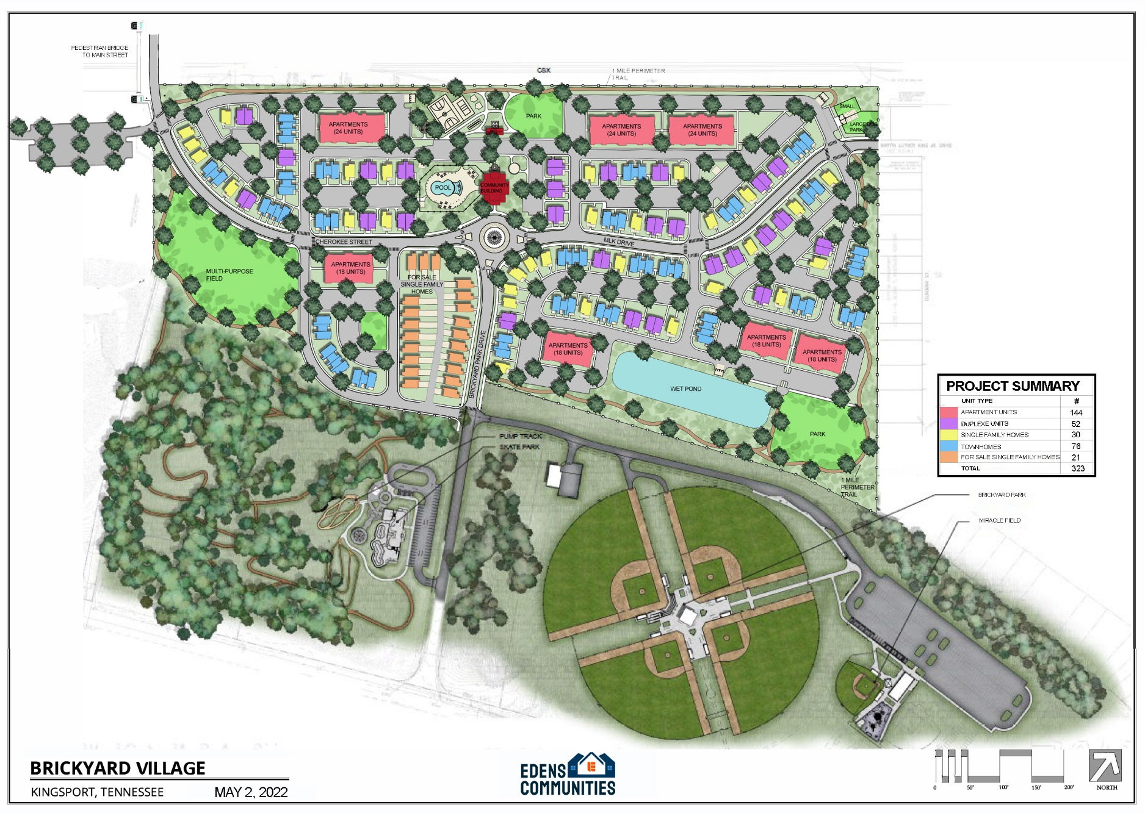

**SITE MAP/LOCATION:**

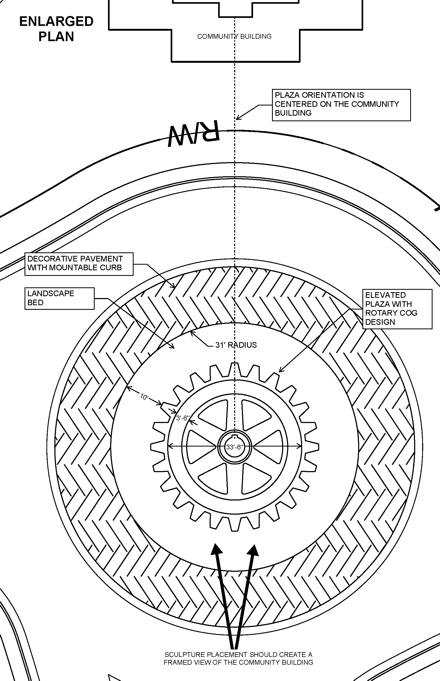

# SELECTION CRITERIA:

The Rotary Club Selection Committee will review the qualifications of applicant artists and will select three finalists. Their selections will be based on the following criteria:

* **Artistic excellence as demonstrated in 10 digital images of the artist(s) previous work**
* **Experience in design and installation of projects of a similar type and scale**
* **Experience working in community settings**
* **Willingness to meet all contractual guidelines**
* **The use of content appropriate for all audiences**
* **Special consideration will be made for sculpture created with indigenous materials.**

# SUBMISSION GUIDELINES:

Submissions shall include the following:

* **Cover letter/letter of intent**
* **Digital portfolio (10 digital images of previous artwork)**

o Include an image list with a thumbnail view of each image submitted

– indicate the budget amount and provide a short description next to each thumbnail

* **Artist’s resume**
* **Contact information for 3 professional references (at least 2 should be from individuals who have commissioned public work from the artist)**

PROJECT SCHEDULE**:

Deadline for Application: August 8, 2022

Notification of Three Finalists: August 17, 2022

Finalist Proposals Due: September 14, 2022

Final Artist Selection: September 28, 2022

The sculpture installation will take place by July 1, 2023.

**Pending on final construction by Brickyard developer, timeline may be adjusted as necessary.

Installation will be scheduled in consultation with the City of Kingsport Office of Cultural Arts. When submitting your RFQ, please confirm that you can work within the timeframe noted above.

# LIST OF RESOURCES:

Deborah Mullins – President, Kingsport Rotary Club

[debjdaugherty@gmail.com](mailto:ckumbhare@johnsoncitytn.org)

Heather Cook – President-Elect, Kingsport Rotary Club

[kingsportrotaryclub@gmail.com](mailto:kingsportrotaryclub@gmail.com)

Hannah Powell – Kingsport Office of Cultural Arts,

[Hannahpowell@kingsporttn.gov](mailto:Hannahpowell@kingsporttn.gov)

423-392-8416

# SUMISSIONS:

*Submit your digital packet to* [*kingsportartentry@gmail.com*](mailto:kingsportartentry@gmail.com)