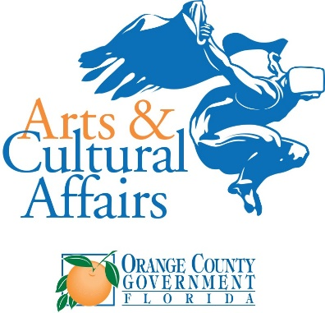

Media Contacts:
Dawn.Knight@ocfl.net
Kelly.Finkelstein@ocfl.net
Jennifer@BisbeeAndCo.com

FOR IMMEDIATE RELEASE
Editor’s note: download images and video here.

Orange County Arts & Cultural Affairs, Orange County Public Schools Unveil
New Student Art Exhibit “Peace and Action”

Orange County, FL (September 19, 2022)—A new juried student art installation called “Peace and Action” launched today at the Orange County Administration Center’s Atrium Gallery. The Student Peace Art Exhibit features creative works by young artists reflecting how they can build peace in their community and world. The art show was unveiled by Orange County Arts & Cultural Affairs and Orange County Public Schools Visual Arts Program, in partnership with the Global Peace Film Festival and GoPegasus.

Orange County Mayor Jerry L. Demings joined with students, parents, teachers, and guests at a reception and awards ceremony today, during which Mayor Demings proclaimed “Global Peace Week” in Orange County. Every participating student artist was honored with a certificate, and prizes were awarded for the best work in four categories. The winning artworks will be featured in a full color calendar and on a GoPegasus luxury coach bus in the region.

“This new art exhibit showcases the talent of Central Florida youth and will inspire the public. The event is an example of public-private partnerships and how to engage the youth in building peace in the community and the world,” said Mayor Demings. “We also hope this event will build relationships that offer academic support, as well as life and job skills training.”

The Student Peace Art Exhibit will be on display to the public in the Orange County Administration Center’s Atrium Galley (201 S. Rosalind Avenue, Orlando, FL 32801) starting today through September 29, 2022, 8 a.m. to 5:30 p.m., Monday through Friday
“We are honored to partner with the Orange County Arts & Cultural Affairs, Orange County Public Schools and the Global Peace Film Festival on our ‘Art on Wheels’ installation,” said GoPegasus Vice President Claudia Menezes. “This collaboration is particularly meaningful as we showcase the works of local students. We care passionately about the arts in our community and helping them to thrive.”

Global Peace Film Festival Executive Director Nina Streich added, "What a great way to celebrate the beginning of Global Peace Week in Orange County than with this wonderful artwork from talented and compassionate students. Participating in this exhibit gave students the opportunity to express their views of what peace means to them and to offer their own ideas of how to promote peace in their schools and community.”

The Global Peace Film Festival kicks off on Tuesday, September 20, 2022 at 6:30 p.m. at the Enzian with the film, World Peace and Other 4th Grade Achievements. It is the story of John Hunter, a teacher in Charlottesville, Virginia, and his students’ participation in an exercise called the World Peace Game , The exercise transformed the children from students of a local school to citizens of the world. Visit peacefilmfest.org for tickets and more information on other Global Peace Week and Global Peace Film Festival events.

About Orange County Arts & Cultural Affairs Office
The mission of Orange County Arts & Cultural Affairs Office is to elevate Central Florida's arts and culture to that befitting a diverse, world-class community.

About the Global Peace Film Festival
Established in 2003, the Global Peace Film Festival (GPFF) uses the power of the moving image to further the cause of peace on earth. From the outset, the GPFF envisioned “peace” not as the absence of conflict but as a framework for channeling, processing and resolving conflict through respectful and non-violent means. People of good faith have real differences that deserve to be discussed, debated and contested. GPFF works to connect expression – artistic, political, social and personal – to positive, respectful vehicles for action and change. The festival program is carefully curated to create a place for open dialogue, using the films as catalysts for change. Visit peacefilmfest.org for more information. Follow @peacefilmfest on Facebook, Instagram, Twitter and YouTube.

About GoPegasus
Headquartered in Orlando, Florida, GoPegasus is a premier travel and transportation planning leader, setting the gold standard for quality and service for 28 years. Since 1994, GoPegasus has delivered the highest level of safe, clean and reliable transportation services in its hometown and throughout the Sunshine State to domestic and global group planning professionals. GoPegasus also serves as a DMC (Destination Management Company). GoPegasus’ innovative “Art on Wheels” program – matching industry-leading organizations with professional artists to create moving murals – extends the company’s commitment to community, clients, excellence and innovation. For more information, visit GoPegasus.com. Follow the company on Facebook, Instagram, Twitter and LinkedIn. #gopegasus #artonwheelsflorida

###

