Annual Sculpture Exhibit - Arts Council Nolanville

Contact Brian O’Connor
boconnor@nolanvilletx.gov
Phone: 254-698-6335

Entry Deadline: 2/24/23

Work Sample Requirements 3-5 Images
Call Type: Sculpture Exhibitions
Eligibility: State of Texas
State: Texas
Event Dates: 5/16/23 - 5/1/24

The Nolanville Art’s Council’s Sculpture Exhibition at the Wonderpass is kicking off the 2023 year. Jurors will accept 4 sculpture pieces for exhibition. Artwork is exhibited for 12 months. In addition to providing installation stipends, the Arts Council Nolanville will award two cash prizes the week of installation.

All forms of outdoor sculpture will be considered, provided it meets the requirements of the prospectus. The exhibit space is at the Main Street Underpass, dubbed “Wonderpass” because of the recent installation of programable lighting. Sculpture will be placed throughout the site at the discretion of the contracted installer and Arts Council Nolanville. The juror for this event is the Arts Council Nolanville that includes Board of Directors of the Nolanville Economic Development Corporation www.nolanvilleedc.org The Nolanville Arts Council is a 501(c)(3) organization and is a subsidiary of the Nolanville Economic Development Corporation.

Installation Location:
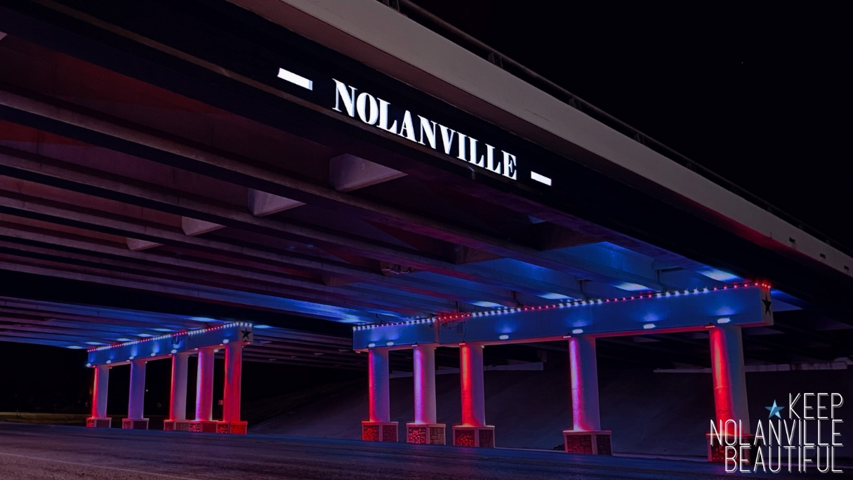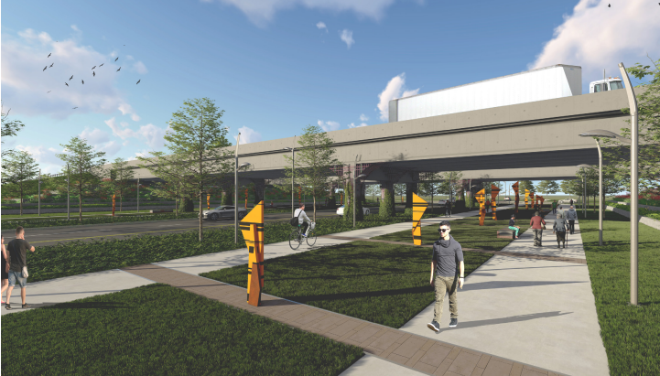
Exhibit 1 Exhibit 2

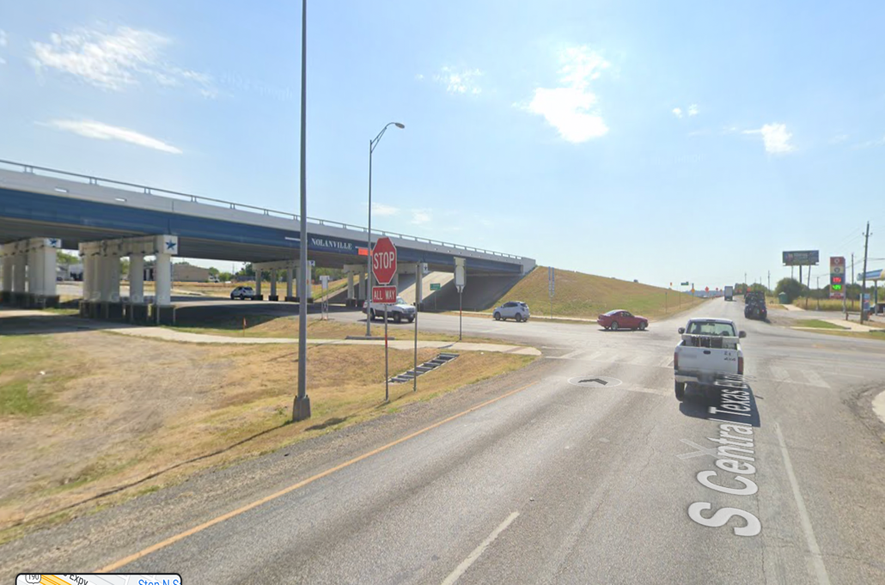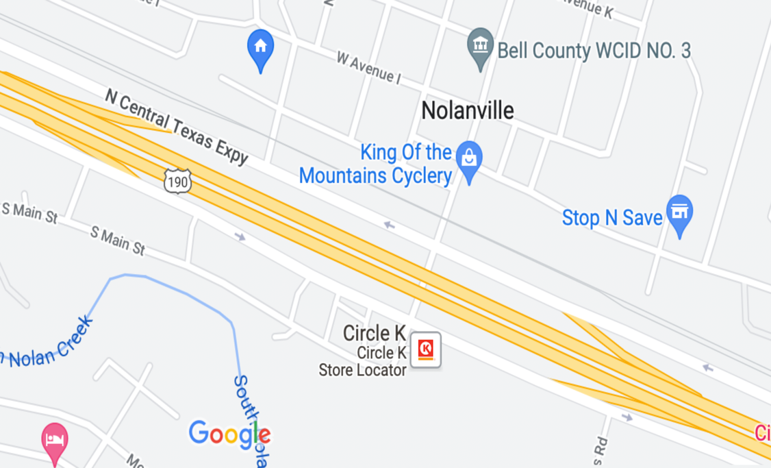

Exhibit 3 Exhibit 4

EXHIBIT AREA
• The exhibit space is located at the underpass of Interstate 14 and Main Street. (Exhibits 1-4)
• Artwork will be seen by approximately 7,500 motorists daily
• Artwork will be mounted on a 5’ x 4’ limestone base and placed on soft ground. There are NO concrete installation areas
available.

EXHIBIT DETAILS
• Duration: Sculptures will be on display for 12 months from installation in May 2023. Artwork must remain on display for the entirety of the exhibit.
• Reception: Accepted artists are encouraged to attend the opening reception on May 17, 2023..
• Stipends: Accepted artists will be provided with an installation stipend totaling $1,500 (one thousand five hundred dollars), to be paid $750 on completed installation and $750 on completed uninstallation.
• Additional support: Accepted artists attending the opening reception will be provided with 1 (one) hotel room for up to 2 (two) nights.
• Awards: Three cash awards will be given as determined by the jurors: 1st, 2nd and 3rd prizes ($2,500, $1,000, $500, respectively).
Awards will be announced at the opening reception. Cash awards will be distributed within 30 days of the opening.
• Uninstallation: Exhibiting artists will be notified of their pick-up date and time by the installer no less than 30 days prior to removal date in 2023. Final stipend payment will be made at the time the sculpture is uninstalled.
Selection Criteria for Exhibits

The Arts Council Nolanville is seeking original sculptural art works in any media suitable for outdoor public space. All sculpture must meet the following basic requirements: 1. The work must be structurally sound to stand-alone or to be secured to a steel or limestone base. The sculpture must be of a scale large enough to be clearly visible. Sculpture should be no smaller than 4’ height and no larger than 10’ height with a 10’ maximum width. 2. The work must be capable of withstanding adverse weather conditions, including hot summers, cold winters, rain, wind, and possible snow. Texas is susceptible to occasional flooding; sculptures should be able to withstand brief and occasional periods of water around the base. 3. The work must be suitable for pedestrian interaction with a low exposure to injury. The public must be protected from possible injury from materials and the work must not include moving parts. 4. The work must be original and preferably (but not necessarily) relatable to features of Nolanville and the Nolan Creek Plan. Works that interact with the wind to create sounds/musical tones are also acceptable. 5. The work must be available for a period of 12 months from installation in late May 2023 to removal in early May 2024. For insurance and marketing purposes, artists are required to indicate whether the sculpture is for sale and the asking price. Artwork does not need to be for sale to be exhibited. However, if is listed for sale, the Nolanville Arts Council is to receive a 10% commission on all sales and will collect and process the appropriate sales tax in addition to the sales price. The Arts Council Nolanville is not responsible for transportation of sold items.

Application Process:
Artists may submit up to 5 pieces of art for consideration. All submissions must be available for display during the May 2023 - May 2024 period. Artists must submit a packet to boconnor@nolanvilletx.gov that includes • Cover Letter for each sculpture, that includes a description of the sculpture. You are to include 3-5 photos of the sculpture(s) in your letter or upload sculpture images with their corresponding titles separately. • Current CV • Artist’s Statement (150 words max) • Image Detail Sheet – Include a thumbnail image of each piece submitted. Label each image with: Entry #, title, medium, date completed, dimensions, weight, and price • Please name each image file using the following format: LASTNAME.#. title.jpg (or png). Images should be submitted via an internet file-sending site or via CD/flash drive by mail. Please note: these materials cannot be returned.

Entries must be received by 5:00 p.m. on February 24, 2023
Application materials must be received no later than 5 PM Central Time on Friday, February 24, 2023. Both online and mailed application materials must be received, not postmarked, by the deadline. Late and/or incomplete proposals will not be accepted.
All forms of outdoor sculpture will be considered, provided it meets the requirements of the prospectus. This includes accepted artists' ability to deliver the artwork in the location specified and, on the date, specified by the installer.

PROPOSED SCHEDULE

Call For Entries open January 10, 2023

Call For Entries closed 5:00PM February 24, 2023

Jurying Completed
March 3, 2023

Artists contracts returned, bio and photo provided to the Arts Council Nolanville March 31, 2023

Artwork installation May 16, 2023
(Date and time will be confirmed with the Installer, Joe Barrington, Artist)

Sculpture Opening Reception / Awards
May 17, 2023

2024 Artists takedown
Tentative date: May 1, 2024
(Date and time will be confirmed with the Installer, Joe Barrington, Artist)

How to Apply:
Artists must submit a digital packet to boconnor@nolanvilletx.gov or mail CD/flash drive by mail to:
Arts Council Nolanville
101 N. 5th Street Nolanville, Texas 76559
ATTN: Brian O’Connor, Arts Council Nolanville, Program Administrator

Questions, Please Contact:
Brian O’Connor Arts Council Nolanville Program Administrator boconnor@nolanvilletx.gov (254) 698-6335

Liability and Waivers
● The Arts Council Nolanville reserves the right to reject any artwork it deems inappropriate for display in the public setting. This includes work deemed purposefully designed to advance any form of discriminatory agenda.
● All photos submitted with the artist’s application must represent the current condition of the work.
● By applying to the exhibition, the Artist certifies to the Arts Council Nolanville that they created and possess unencumbered title to the sculpture(s) they are submitting to the Wonderpass Exhibit.
● Arts Council Nolanville and its affiliates will not be liable for the degradation of objects caused by normal outdoor wear and tear. Insured artwork will be insured for the replacement value stated by the artist, however, claims will only be made for circumstances beyond “normal wear and tear” of outdoor display.
● Artists will allow the Arts Council Nolanville and its affiliates to photograph and publish photos and information related to the Art’s work. Artists will be given recognition of any artwork displayed. Artists agree to include all biographical and art-work related information for promotion of the exhibit.
● Arts agree to provide the Arts Council Nolanville with appropriate information in a timely manner as requested (including but not limited to artists bio/statement, current contact information, artists photo, relevant social media links, etc.)

