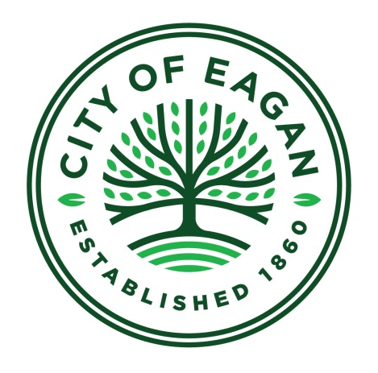

Request for Qualifications

Art Bench Project in Eagan, Minnesota
2018

Eagan Parks & Recreation seeks artists to produce four benches for placement in the City parks, facilities and along the Park trail system in 2018.

Background and project theme
In 2017, the City of Eagan installed four art benches in an effort to add to the City’s sense of place, while enhancing resting areas for its residents. In 2018, Eagan Parks & Recreation will install four additional artist designed and produced benches to represent the unique landscape and neighborhoods of identified locations.

Identified Art Bench Sites
- Eagan Community Center, Interior – Home to Eagan Fitness Center, meeting and special event space, and three gymnasiums. Over 1,200 people per week.
- Thresher Fields – Soccer fields, adjacent dog park, walking trails
- Blackhawk Park – Pavilion, sand volleyball, lake, walking trails
- Holz Farm Park – Neighborhood park adjacent to Historic 1940’s Holz Farm.

General Specifications
- Must accommodate up to 500 pounds for seating
- Maximum length, 8 feet. Entire design must stay within 8 feet.
- Height, minimum 17 inches. Maximum height may vary depending on the site.
- Durable construction suitable for outdoor conditions.
- Bench must include mounting mechanism for surface installation to a concrete pad. Eagan Parks maintenance staff will install a concrete pad at each location. Artist is responsible for artwork transport to designated location and for final installation.

Budget
$3,000 per bench, inclusive of all costs including installation. Selected finalists will be paid $200 for proposal development.

Eligibility
Applicants must reside in the State of Minnesota or demonstrate a significant established connection to Minnesota.

Submission Requirements
Interested artists should submit the following materials:
- A letter of interest of 500 words maximum, with contact information, artistic approach and why your artwork would be compatible for this project.
- Up to 5 images of work samples with descriptions and estimated cost of each.
- Professional resume, maximum two pages.

Submission materials must be received by Friday, January 12 at 4:30 p.m.

E-mail submissions are preferred at: jandersen@cityofeagan.com.

You may also mail materials to the attention of:
Julie Andersen
Eagan Parks & Recreation
3830 Pilot Knob Road
Eagan, MN 55122

All applications will receive an e-mail acknowledgement within three days of receipt.

Timeline:
- January 12, 2018 – RFQ submissions due
- January 23, 2018 – Finalist notified and invited for proposal development
- February 28 – March 1, 2018 – Finalist interviews
- March 2 – April 2, 2018 - 30 day public review period for finalist proposals
- April 3, 2018 - City Council approval
- Installation begins June, 2018

Schedule subject to change.

Please direct questions about the project to Julie Andersen at jandersen@cityofeagan.com or 651-675-5521.

