MEDIA CONTACT
Whitney Radley, The CKP Group
whitney@theckpgroup.com
832-930-4065 x 106
FOR IMMEDIATE RELEASE
October 30, 2017
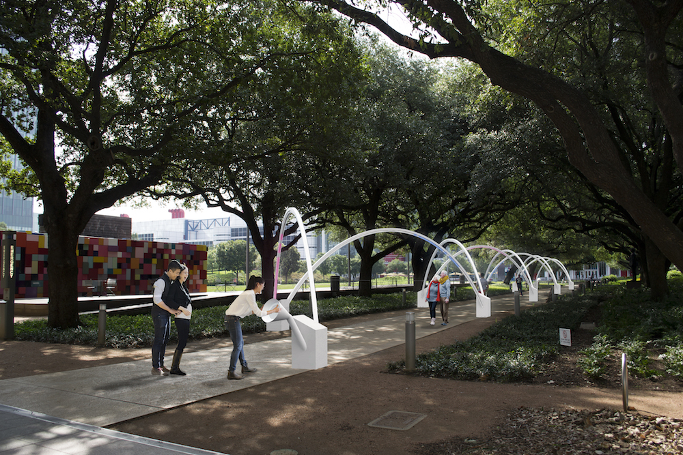

Discovery Green® commissions new public art installation
by Daily tous les jours

Hello, Trees! A Walking Serenade opens on November 18

HOUSTON, TX — Discovery Green announces the creation of Hello, Trees! A Walking Serenade, a site-specific work by the Montreal-based design studio Daily tous les jours. This interactive installation—the park’s first original commission—uses public participation to create an immersive light and sound experience that is unique to each visitor. The work will be on view from November 18, 2017, through February 25, 2018.

“The Discovery Green Conservancy has established a strong public art program since the park opened in 2008, so it is fitting that this landmark commission opens on the cusp of our 10-year anniversary,” said Barry Mandel, president of Discovery Green Conservancy. “We are thrilled to continue our tradition of innovative seasonal light presentations with Daily tous les jours’ magical piece along the Brown Foundation Promenade.”

Taking inspiration from the century-old live oaks that form the heart of the park, Daily tous les jours conceived Hello, Trees! as a metaphor for the way trees use nonverbal cues to communicate complex information. Comprised of a series of arches under the live oak canopy, visitors are invited to speak into input stations located at each end of the sculpture, and their voice messages are translated into light patterns that travel along the arches. The original voice input is gradually transformed into a musical melody as the light reaches the base of each arch. When two messages meet, a special light and sound effect is triggered; the result is an immersive experience that Daily tous les jours likens to a “crowd-sourced concerto,” changing gradually as visitors walk underneath the installation and mimicking the way trees create pathways of communication. New scientific discoveries of trees as social beings have found that, to increase their resilience, trees utilize communication in many forms to share needs and provide mutual assistance.

Hello, Trees! was curated by the Conservancy’s Public Art Committee, a group of community experts dedicated to bringing original, inspiring art to Discovery Green.

“We admired work from Daily tous les jours and asked them to visit Discovery Green as a potential installation site,” said Judy Nyquist, chair of the Conservancy’s Public Art Committee. “Following multiple discussions and extensive research, the design team proposed an entirely new work of art for the park that highlights one of our most distinctive features—the majestic oak trees. This original commission is a major milestone for Discovery Green’s temporary public art program.”

Co-founded by Melissa Mongiat and Mouna Andraos in 2010, Daily tous les jours is best known for placing work in public spaces, where crowds are invited to engage with the art and with each other, and to collectively participate in the transformation of their city. The studio has received numerous recognitions—notably the Best in Show at the Interaction Awards, the Grand Prize at the UNESCO Shenzhen Awards and the Knight Cities Challenge Prize—for their world-renowned project Musical Swings. They have also recently received the Fast Company Innovation by Design Award and the Americans for the Arts Public Art Network Award.

“We’ve explored ways for Discovery Green crowds to engage with the nature around them, inviting passersby to slow down and take part in this poetic attempt to communicate with trees,” said Mongiat of Daily tous les jours.

Discovery Green invites the public to an artist talk on Friday, November 17, 2017, at 6 p.m. on the Hess Deck, overlooking Hello, Trees! Additional programming is planned throughout the run of the installation.

Visitors are invited to share their experiences using the hashtags #discoverygreen and #hellotrees. More information is available at www.discoverygreen.com/hellotrees.

Discovery Green’s programming is made possible in part by generous funders including The Brown Foundation, Kinder Foundation, Sterling Turner Charitable Foundation, Winston Charitable Foundation and by a grant from the City of Houston through the Houston Arts Alliance. Hotel accommodations provided by the Marriott Marquis Houston/RIDA Development Corporation. Professional services provided by the Weingarten Art Group.
A digital press kit with high-res images and a video rendering is available at bit.ly/HelloTreesPress.
About Discovery Green
Discovery Green is a highly acclaimed 12-acre park created by a public-private partnership between the City of Houston and the non-profit Discovery Green Conservancy in downtown Houston. Since opening in April 2008, the park has welcomed more than 12 million visitors. The Discovery Green Conservancy works with hundreds of programming partners to present more than 600 art, music, educational, fun and healthy events each year, most of which are presented free to the public. As a non-profit organization, the Conservancy raises all the funds needed for the programming that Houstonians enjoy.
About Weingarten Art Group
Weingarten Art Group is an award-winning boutique art advisory firm with offices in Houston and New York. The firm specializes in providing private, public, institutional and corporate clients with services that include curatorial direction, artwork sourcing, strategic planning with architects/designers, project management and budget optimization. An active participant in multiple art organizations, Lea Weingarten is Chair of the Menil Society Steering Committee (Menil Collection) and has served on the boards and prominent committees of the Contemporary Arts Museum Houston and the Museum of Fine Arts, Houston.
# # #
Discovery Green. Reg. U.S. Pat. & Tm. Off.

