CONTRACT DOCUMENTS FOR:

RFP #009-18
ARTS & CULTURE MASTER PLAN FOR
TRUMAN WATERFRONT PARK

MAY 2018

MAYOR: Craig Cates

COMMISSIONERS:
JIMMY WEEKLEY  BILLY WARDLOW  MARGARET ROMERO | SAMUEL KAUFMAN  RICHARD G. PAYNE  CLAYTON LOPEZ

PREPARED BY: RFP DOCUMENTS
City of Key West
Planning Department

CITY OF KEY WEST

KEY WEST, FLORIDA

DOCUMENTS

for

ARTS & CULTURE MASTER PLAN FOR
TRUMAN WATERFRONT PARK

KEY WEST, FLORIDA

MAY 2018

Table of Contents

PART 1 - GENERAL PROPOSAL REQUIREMENTS Page No.

REQUEST FOR PROPOSAL 5
INSTRUCTIONS TO PROPOSER 7
INSURANCE REQUIREMENTS 12
REQUIRED QUALIFICATIONS 13
PROPOSAL SUBMITTAL REQUIREMENTS 13
NON-COLLUSION AFFIDAVIT 16
ANTI – KICKBACK AFFIDAVIT 17
FLORIDA STATUTES, ON PUBLIC ENTITY CRIMES 18
INDEMNIFICATION FORM 21
DOMESTIC PARTNERSHIP AFFIDAVIT………………………………... 22
CONE OF SILENCE AFFIDAVIT…………………………………………. 23

PART 2 - SCOPE OF SERVICES 27

PART 3 – SUPPLEMENTAL INFORMATION 31

PART 4 – GRANT INFORMATION 34

ATTACHMENT A GRANT TERMS & CONDITIONS 35
ATTACHMENT B APPENDIX II TO PART 200 56
ATTACHMENT C AFFIRMATIVE STEPS 58
ATTACHMENT D CERTIFICATIONS & ASSURANCES 59

PART 5 - DRAFT AGREEMENT 66

PART 1

GENERAL PROPOSAL

REQUIREMENTS

REQUEST FOR PROPOSAL

Sealed bids for the City of Key West (City) RFP #009-18 ARTS & CULTURE MASTER PLAN CONSULTANT FOR TRUMAN WATERFRONT PARK, addressed to the City of Key West, will be received at the Office of the City Clerk, 1300 White St., Key West Florida, 33040 until 3:00 pm on June 20, 2018 and then will be publicly opened and read. Any bids received after the time and date specified will not be considered.

Please submit one (1) original and two (2) flash drives with one single PDF file of the sections entitled “Proposal Requirements” and “Contract Forms”. Proposal package is to be enclosed in a sealed envelope, clearly marked on the outside “PROPOSAL FOR ARTS & CULTURE MASTER PLAN CONSULTANT – TRUMAN WATERFRONT PARK” addressed and delivered to the City Clerk at the address noted above.

The City via the City of Key West Arts in Public Places (AIPP) and Truman Waterfront Advisory Board (TWAB) is seeking proposals from qualified individuals or firms to develop a Truman Waterfront Arts & Culture Master Plan that includes creative placemaking to strengthen the community and connect Key West’s Historic Old Town and the waterfront park area as a community place to gather. Successful applicants will demonstrate expertise in public art and master planning for rural and/or small cities with an emphasis on naval history, marine environments, sustainability and ecological art with a purpose.

The full Request for Proposal may be obtained from Demand Star by Onvia and The City of Key West website. Contact Demand Star at www.demandstar.com or call 1-800-711-1712 or www.cityofkeywest-fl.gov.

The Proposer will be required to furnish documentation with his proposal showing that he is in compliance with any and all licensing requirements of the State.

The Proposer shall furnish documentation showing that he is in compliance with the licensing requirements of the provisions of Chapter 66 Section 87 of the Code of Ordinances of the City of Key West; within 10 days the following the Notice of Award and must demonstrate that he holds at a minimum, the following licenses & certificates;

- City of Key West Business Tax License Receipt

Compliance with these provisions is required before the Firm can enter into the agreement contained in the Contract Documents.

All insurance contracts and certificates of shall be either executed by or countersigned by a licensed resident agent of the Surety or Insurance Company having his place of business in the State of Florida, and in all ways complying with the insurance laws of the State of Florida. Further, the said Surety or Insurance Company shall be duly licensed and qualified to do business in the State of Florida.

Before a Contract will be awarded for the work contemplated herein, the AIPP and TWAB, on behalf of the City, will conduct such investigation as is necessary to determine the performance record and ability of the Proposer to perform the size and type of work specified under this Contract. Upon request, the Proposer shall submit such information as deemed necessary by the AIPP and TWAB to evaluate the Proposer's qualifications.

For information concerning the proposed work please contact Carolyn Sheldon, Senior Grants Administrator, by email at csheldon@cityofkeywest-fl.gov. Verbal communications, per the City’s “Cone of Silence” ordinance are not allowed.

As stated above at the time of the proposal submittal the Proposer must provide satisfactory documentation of State Licenses. The Proposer shall furnish documentation showing that he is in compliance with the licensing requirements of County, and City licenses as would be required within ten days of the award. The successful Proposer must also be able to satisfy the City Attorney as to such insurance coverage and legal requirements as may be demanded by the Proposal in question. The AIPP and TWAB may reject proposal for any and/or all of the following reasons: (1) for budgetary reasons, (2) if the proposer misstates or conceals a material fact in its bid, (3) if the proposal does not strictly conform to the law or is non-responsive to the bid requirements, (4) if the proposal is conditional, or (5) if a change of circumstances occurs making the purpose of the proposal unnecessary to the AIPP and TWAB. (6) if such rejection is in the best interest of the City. The City may also waive any minor formalities or irregularities in any proposal.

INSTRUCTIONS TO PROPOSER

1. CONTRACT DOCUMENTS

A. FORMAT

The Contract Documents are divided into parts, divisions, and sections for convenient organization and reference. Generally, there has been no attempt to divide the sections into work performed.

B. DOCUMENT INTERPRETATION

The separate sections contained within these Contract Documents are intended to be mutually cooperative and to provide all details reasonably required for the execution of the proposed work.

Should there be any doubt as to the meaning or intent of said Contract Documents, the Proposer should request of the Sustainability Coordinator, in writing (at least 8 calendar days prior to bid opening) an interpretation thereof. Any interpretation or change in said Contract Documents will be made only in writing in the form of Addenda to the documents which will be furnished to all registered holders of Contract Documents. Proposers shall submit with their Proposals, or indicate receipt of, all Addenda. The CITY will not be responsible for any other explanation or interpretations of said Documents.

2. SCOPE OF SERVICES

A general description of the proposed scope of work is contained in the Scope of Services section.

3. REQUIRED QUALIFICATIONS

The prospective Proposers must meet the statutorily prescribed requirements before award of Contract by the CITY. Proposers must hold or obtain all licenses and/or certificates as required by the State and Local Statutes in order to bid and perform the work specified herein. Additionally, all proposers must meet the minimum qualifications as described in Required Qualifications section.

Proposer must have been in existence as a business in their home state for a continuous period of five (5) years prior to the date of this RFP.

4. PROPOSERS UNDERSTANDING

Each Proposer must inform himself of the conditions relating to the execution of the work and make himself thoroughly familiar with all the Contract Documents. Failure to do so will not relieve the successful Proposer of his obligation to enter into a Contract and complete the contemplated work in strict accordance with the Contract Documents.

Each Proposer shall inform himself of, and the Proposer awarded a Contract shall comply with, federal, state, and local laws, statutes, and ordinances relative to the execution of the work. This requirement includes, but is not limited to, applicable regulations concerning minimum wage rates, nondiscrimination in the employment of labor, protection of public and employee safety and health, environmental protection, the protection of natural resources, fire protection, permits, fees, and similar subjects.

5. TYPE OF PROPOSAL

A. NOT-TO-EXCEED LUMP SUM
- The City anticipates work to be performed through Scope of Service Tasks with payment for services on a per Task lump sum milestone payment. The City reserves the right to negotiate a compensation package that is fair and reasonable to the City, as determined solely by City. All costs including travel are to be included in your proposal. The City will not accept any additional costs.

Task | Description | Not-to-Exceed Milestone Payment
A | Project Administration | $ 10,000
B | Public Engagement | $ 20,000
C | EcoArt Workshop | $ 12,000
D | Truman Waterfront Arts & Culture Master Plan | $ 30,000
E | Public Art Performance | $ 3,000
 | TOTAL AWARD: | $ 75,000

6. PREPARATION OF PROPOSAL

A. GENERAL

All blank spaces in the PROPOSAL form must be filled in, as required, preferably in BLACK ink. No changes shall be made in the phraseology of the forms.

Any PROPOSAL shall be deemed informal which contains omissions, erasures, alterations, or additions of any kind, or prices uncalled for, or in which any of the prices are obviously unbalanced, or which in any manner shall fail to conform to the conditions of the published Request for Proposal.

Only one PROPOSAL from any individual, firm, partnership, or corporation, under the same or different names, will be considered. Should it appear to the CITY that any Proposer is interested in more than one Proposal for work contemplated; all Proposals in which such Proposer is interested will be rejected.

B. SIGNATURE

The Proposer shall sign his PROPOSAL in the blank space provided therefore. If Proposer is a corporation, the legal name of the corporation shall be set forth above, together with the signature of the officer or officers authorized to sign Contracts on behalf of the corporation. If Proposer is a partnership, the true name of the firm shall be set forth above, together with the signature of the partner or partners authorized to sign Contracts in behalf of the partnership. If signature is by an agent, other than an officer of a corporation or a member of a partnership, a notarized power-of-attorney must be on file with the CITY prior to opening of Proposals or submitted with the Proposal, otherwise the Proposal will be regarded as not properly authorized.

C. ATTACHMENTS

Proposer shall complete and submit the following forms with his proposal:

- Anti-Kickback Affidavit
- Sworn Statement under section 287.133(3)(a) Florida Statutes, on public entity crimes
- Indemnification Form
- Domestic Partnership Affidavit
- Cone of Silence Affidavit
- Non-Collusion Affidavit
- All requirements listed in Proposal Submittal Requirements
- Proof of Insurance

7. STATE AND LOCAL SALES AND USE TAXES

Unless the contract documents contain a statement that the CITY is exempt from state sales tax on materials incorporated into the work due to the qualification of the work under this Contract, the Contractor, as required by the laws and statutes of the state and its political subdivisions, shall pay all state and local sales and use taxes. Prices quoted in the Proposal shall include all nonexempt sales and use taxes, unless provision is made in the Proposal form to separately itemize the tax.

8. SUBMISSION OF PROPOSALS

All PROPOSALS must be submitted not later than the time prescribed, at the place, and in the manner set forth in the Request for Proposals.

PROPOSALS must be made on the PROPOSAL forms provided herewith, submit one (1) ORIGINAL bid package and two (2) FLASH DRIVES containing a single PDF file of the entire bid package.

Each PROPOSAL must be submitted in a sealed envelope, so marked as to indicate the Proposer's name and its contents (project name and number) without being opened, and addressed in conformance with the instructions in the Request for Proposals.
9. MODIFICATION OR WITHDRAWAL OF PROPOSALS

Prior to the time and date designated for receipt of PROPOSALS, any PROPOSAL submitted may be withdrawn by notice to the party receiving PROPOSALS at the place designated for receipt of PROPOSALS. Such notice shall be in writing over the signature of the Proposer or by email. If by email, written confirmation over the signature of the Proposer shall be mailed and postmarked on or before the date and time set for receipt of PROPOSAL. No PROPOSAL may be withdrawn after the time scheduled for opening of PROPOSALS, unless the time specified in paragraph AWARD OF CONTRACT of these Instructions to Proposers shall have elapsed.

10. AWARD OF CONTRACT

Within ninety (90) calendar days after the opening of Proposals, the CITY will accept one of the Proposals or will act in accordance with the following paragraphs. The acceptance of the Proposal will be by written notice of award, mailed to the office designated in the Proposal, or delivered to the Proposer's representative. In the event of failure of the highest ranked Proposer to sign the Contract and provide acceptable insurance certificate(s) and evidence of holding required licenses and certificates, the Owner may award the Contract to the second ranked Proposer. Such award, if made, will be made within one hundred-twenty (120) days after the opening of Proposals.

The CITY reserves the right to accept or reject any or all Proposals, and to waive any informalities and irregularities in said Proposals.

11. BASIS OF AWARD

A selection committee will evaluate all proposals that meet the minimum qualifications of this RFP. Each committee member shall complete an evaluation sheet ranking each qualified proposer against the weighted criteria set forth below. Completed evaluations shall be combined and tallied. The City reserves the right to interview one or more of the highest ranked candidates. Upon completion of its evaluation process, the evaluation committee shall provide the results of the scoring and ranking and award recommendation to the AIPP. The AIPP will subsequently provide the City Commission a recommendation to award the contract to the highest ranked Proposer. If the City and the highest ranked Proposer are unable for any reason to negotiate a contract the City shall, either orally or in writing, formally terminate negotiations with the selected firm. The City may then negotiate with the next highest ranked firm. The negotiation process may continue in this manner through successive firms until an agreement is reached or the City terminates this RFP.

The selection committee will shortlist no less than 3 firms, unless less than 3 firms submit proposals, based on the selection criteria on the next page:

SELECTION CRITERIA | Maximum Points
Past performance on similar projects | 25
Approach and methodology for project | 35
Experience and resume | 20
References | 10
Overall presentation | 10
POINT TOTAL | 100

12. EXECUTION OF CONTRACT

The successful Proposer shall, within ten (10) working days after receiving Notice of Award, sign and deliver to the CITY two (2) original Contracts in the form hereto attached, together with the insurance certificate examples of the bonds as required in the Contract Documents and evidence of holding required licenses and certificates. Within 10 working days after receiving the signed Contract from the successful Proposer, the City’s authorized agent will sign the Contract. Signature by both parties constitutes execution of the Contract.

13. TERM OF CONTRACT

It is anticipated that the CITY will enter into a one (1) year agreement, which thereafter may be extended upon written consent of both parties for an additional six (6) month term.

- PROPOSER'S DECLARATION AND UNDERSTANDING

The undersigned, hereinafter called the Proposer, declares that the only persons or parties interested in this Proposal are those named herein, that this Proposal is, in all respects, fair and without fraud, that it is made without collusion with any official of the Owner, and that the Proposal is made without any connection or collusion with any person submitting another Proposal on this Contract.

The Proposer further declares that he has carefully examined the Contract Documents and that this Proposal is made according to the provisions and under the terms of the Contract Documents, which Documents are hereby made a part of this Proposal.

- ADDENDA

The Proposer hereby acknowledges that he has received Addenda No's. , , . Proposer shall insert No. of each Addendum received) and agrees that all addenda issued are hereby made part of the Contract Documents, and the Proposer further agrees that his Proposal(s) includes all impacts resulting from said addenda.

- INSURANCE REQUIREMENTS

Refer to Article 4 of the Draft Consulting Agreement for project insurance requirements.

REQUIRED QUALIFICATIONS

Proposers shall have substantial experience with the following:

    - Proposer must have been in existence as a business in their home state for a continuous period of five (5) years prior to the date of this RFP.

    - Although not required, it is preferred that the Proposer have at least two (2) years experience in public art and master planning for rural and/or small cities with an emphasis on marine environments, sustainability and ecological environment and global art with a purpose for a local government agency.

PROPOSAL SUBMITTAL REQUIREMENTS

Proposals shall be limited to 20 sheets (front and back, equals 40 pages) and include, at a minimum, the following items:

- Cover Letter: A one-page cover letter containing:
- The name of the person(s) authorized to represent the Proposer in negotiating and signing any agreement which may result from the proposal;
- Entity name, address, phone, website and email address,
- Provide a brief description of your team, including its founding and history; number of employees; service areas; and, awards or other forms of recognition.
- Qualifications - Description of relevant experience with NEA grants and providing similar master plans.
- Methodology and Approach - Descriptions which enable the City to assess the proposer’s capability to conduct a place-based, community engagement process to create the Arts & Culture Master Plan for Truman Waterfront. At a minimum this should include: Project understanding; community engagement approach; place making experience, and proposed schedule for completion of Tasks within scope of services;
- Current Resume(s)
- Organization Chart – Show prime consultant, and as well as any sub-consultants or key personnel.
- Provide a minimum of two (2) client references.
- Explain proposer’s workload capacity with the level of service and deadlines required by the City.
- All required attachments listed in Instructions to Proposer. NOT COUNTED TOWARDS 20 SHEET LIMIT
THE FOLLOWING WILL BE SUBMITTED WITH THE PROPOSAL

List items to be performed by CONTRACTOR’s own forces and the estimated total cost of these items. (Use additional sheets if necessary.)

SUBCONTRACTORS

The Proposer further proposes that the following subcontracting firms or businesses will be awarded subcontracts for the following portions of the work in the event that the Proposer is awarded the Contract:

Name

, , , Street City State Zip

Name

, , ,
Street City State Zip

PROPOSER

The name of the Proposer submitting this Proposal is

doing business at

, , ,
Street City State Zip

which is the address to which all communications concerned with this Proposal and with the Contract shall be sent.

The names of the principal officers of the corporation submitting this Proposal, or of the partnership, or of all persons interested in this Proposal as principals are as follows:

If Sole Proprietor or Partnership

IN WITNESS hereto the undersigned has set his (its) hand this day of 2018.

Signature of Proposer

Title

If Corporation

IN WITNESS WHEREOF the undersigned corporation has caused this instrument to be executed and its seal affixed by its duly authorized officers this day of 2018.

(SEAL)

Name of Corporation

By

Title

Attest

Sworn and subscribed before this ___________ day of ________________, 20____

NOTARY PUBLIC, State of _____________________, at Large

My Commission Expires: ________________

NON-COLLUSION AFFIDAVIT

STATE OF FLORIDA )
: SS COUNTY OF MONROE )

I, the undersigned hereby declares that the only persons or parties interested in this Proposal are those named herein, that this Proposal is, in all respects, fair and without fraud, that it is made without collusion with any official of the Owner, and that the Proposal is made without any connection or collusion with any person submitting another Proposal on this Contract.

By:

Sworn and subscribed before me this

day of , 2018.

NOTARY PUBLIC, State of Florida at Large

My Commission Expires:

ANTI – KICKBACK AFFIDAVIT

STATE OF ______________ )
: SS
COUNTY OF ____________ )

I, the undersigned hereby duly sworn, depose and say that no portion of the sum herein bid will be paid to any employees of the City of Key West as a commission, kickback, reward or gift, directly or indirectly by me or any member of my firm or by an officer of the corporation.

By:

Sworn and subscribed before me this day of , 2018.

NOTARY PUBLIC, State of ______________ at Large

My Commission Expires:

SWORN STATEMENT UNDER SECTION 287.133(3)(A)
FLORIDA STATUTES, ON PUBLIC ENTITY CRIMES

THIS FORM MUST BE SIGNED IN THE PRESENCE OF A NOTARY PUBLIC OR OTHER OFFICER AUTHORIZED TO ADMINISTER OATHS.

- This sworn statement is submitted with Bid or Proposal for ______
______

- This sworn statement is submitted by ______
(Name of entity submitting sworn statement)

whose business address is ______
______
and (if applicable) its Federal Employer Identification Number (FEIN) is ____________
(If the entity has no FEIN, include the Social Security Number of the individual

signing this sworn statement ______

- My name is ______
(Please print name of individual signing)

and my relationship to the entity named above is ______

- I understand that a “public entity crime” as defined in Paragraph 287.133(1)(g), Florida Statutes, means a violation of any state or federal law by a person with respect to and directly related to the transaction of business with any public entity or with an agency or political subdivision of any other state or with the United States, including but not limited to, any bid or contract for goods or services to be provided to any public or an agency or political subdivision of any other state or of the United States and involving antitrust, fraud, theft, bribery, collusion, racketeering, conspiracy, material misrepresentation.

- I understand that “convicted” or “conviction” as defined in Paragraph 287.133(1)(b), Florida Statutes, means a finding of guilt or a conviction of a public entity crime, with or without an adjudication guilt, in any federal or state trial court of record relating to charges brought by indictment information after July 1, 1989, as a result of a jury verdict, nonjury trial, or entry of a plea of guilty or nolo contendere.

- I understand that an “affiliate” as defined in Paragraph 287.133(1)(a), Florida Statutes, means
  - A predecessor or successor of a person convicted of a public entity crime; or

  - An entity under the control of any natural person who is active in the management of the entity and who has been convicted of a public entity crime. The term “affiliate” includes those officers, directors, executives, partners, shareholders, employees, members, and agents who are active in the management of an affiliate. The ownership by one person of shares constituting controlling interest in another person, or a pooling of equipment or income among persons when not for fair market value under an arm’s length agreement, shall be a prima facie case that one person controls another person. A person who knowingly enters into a joint venture with a person who has been convicted of a public entity crime in Florida during the preceding 36 months shall be considered an affiliate.

- I understand that a “person” as defined in Paragraph 287.133(1)(8), Florida Statutes, means any natural person or entity organized under the laws of any state or of the United States with the legal power to enter into a binding contract and which bids or applies to bid on contracts for the provision of goods or services let by a public entity, or which otherwise transacts or applies to transact business with public entity. The term “person” includes those officers, directors, executives, partners, shareholders, employees, members, and agents who are active in management of an entity.

- Based on information and belief, the statement which I have marked below is true in relation to the entity submitting this sworn statement. (Please indicate which statement applies).

____Neither the entity submitting this sworn statement, nor any officers, directors, executives, partners, shareholders, employees, members, or agents who are active in management of the entity, nor any affiliate of the entity have been charged with and convicted of a public entity crime subsequent to July 1, 1989, AND (Please indicate which additional statement applies.)

_____There has been a proceeding concerning the conviction before a hearing of the State of Florida, Division of Administrative Hearings. The final order entered by the hearing officer did not place the person or affiliate on the convicted VENDOR list. (Please attach a copy of the final order.)

_____The person or affiliate was placed on the convicted VENDOR list. There has been a subsequent proceeding before a hearing officer of the State of

Florida, Division of Administrative Hearings. The final order entered by the hearing officer determined that it was in the public interest to remove the person or affiliate from the convicted VENDOR list. (Please attach a copy of the final order.)

_____The person or affiliate has not been put on the convicted VENDOR list. (Please describe any action taken by or pending with the Department of General Services.)

__________________________________________
(Signature)
__________________________________________
(Date)

STATE OF___________________

COUNTY OF_________________

PERSONALLY APPEARED BEFORE ME, the undersigned authority,

_________________________who, after first being sworn by me, affixed his/her
(Name of individual signing)

Signature in the space provided above on this____day of , 2018.

My commission expires:
__________________________
NOTARY PUBLIC

CITY OF KEY WEST INDEMNIFICATION FORM

To the fullest extent permitted by law, the VENDOR expressly agrees to indemnify and hold harmless the City of Key West, their officers, directors, agents and employees (herein called the “indemnitees”) from any and all liability for damages, including, if allowed by law, reasonable attorney’s fees and court costs, such legal expenses to include costs incurred in establishing the indemnification and other rights agreed to in this Paragraph, to persons or property, caused in whole or in part by any act, omission, or default by VENDOR or its subcontractors, material men, or agents of any tier or their employees, arising out of this agreement or its performance, including any such damages caused in whole or in part by any act, omission or default of any indemnitee, but specifically excluding any claims of, or damages against an indemnitee resulting from such indemnitee’s gross negligence, or the willful, wanton or intentional misconduct of such indemnitee or for statutory violation or punitive damages except and to the extent the statutory violation or punitive damages are caused by or result from the acts or omissions of the VENDOR or its subcontractors, material men or agents of any tier or their respective employees.

VENDOR: ______________________________________________ SEAL:

______________________________________________
Address
______________________________________________
Signature
______________________________________________
Print Name
______________________________________________
Title

DATE: ______________________________________________

Sworn and subscribed before this ___________ day of __________________________, 20____

NOTARY PUBLIC, State of _____________________, at Large

My Commission Expires: ________________

EQUAL BENEFITS FOR DOMESTIC PARTNERS AFFIDAVIT

STATE OF __________________ )
: SS
COUNTY OF ________________ )

I, the undersigned hereby duly sworn, depose and say that the firm of ______________________ provides benefits to domestic partners of its employees on the same basis as it provides benefits to employees’ spouses per City of Key West Ordinance Sec. 2-799.

By: __________________________

Sworn and subscribed before this ___________ day of __________________________, 20____

NOTARY PUBLIC, State of _____________________, at Large

My Commission Expires: ________________

CONE OF SILENCE AFFIDAVIT

STATE OF ________________ )
: SS
COUNTY OF ________________ )

I the undersigned hereby duly sworn depose and say that all owner(s), partners, officers, directors, employees and agents representing the firm of _______________________________ have read and understand the limitations and procedures regarding communications concerning City of Key West issued competitive solicitations pursuant to City of Key West Ordinance Section 2-773 Cone of Silence (attached).

By:

Sworn and subscribed before me this

day of 20 .

NOTARY PUBLIC, State of at Large

My Commission Expires:

Sec. 2-773. - Cone of silence.
(a) Definitions. For purposes of this section, reference to one gender shall include the other, use of the plural shall include the singular, and use of the singular shall include the plural. The following definitions apply unless the context in which the word or phrase is used requires a different definition:
(1) Competitive solicitation means a formal process by the City of Key West relating to the acquisition of goods or services, which process is intended to provide an equal and open opportunity to qualified persons and entities to be selected to provide the goods or services. Completive solicitation shall include request for proposals ("RFP"), request for qualifications ("RFQ"), request for letters of interest ("RFLI"), invitation to bid ("ITB") or any other advertised solicitation.
(2) Cone of silence means a period of time during which there is a prohibition on communication regarding a particular competitive solicitation.
(3) Evaluation or selection committee means a group of persons appointed or designated by the city to evaluate, rank, select, or make a recommendation regarding a vendor or the vendor's response to the competitive solicitation. A member of such a committee shall be deemed a city official for the purposes of subsection (c) below.
(4) Vendor means a person or entity that has entered into or that desires to enter into a contract with the City of Key West or that seeks an award from the city to provide goods, perform a service, render an opinion or advice, or make a recommendation related to a competitive solicitation for compensation or other consideration.
(5) Vendor's representative means an owner, individual, employee, partner, officer, or member of the board of directors of a vendor, or a consultant, lobbyist, or actual or potential subcontractor or sub-consultant who acts at the behest of a vendor in communicating regarding a competitive solicitation.
(b) Prohibited communications. A cone of silence shall be in effect during the course of a competitive solicitation and prohibit:
(1) Any communication regarding a particular competitive solicitation between a potential vendor or vendor's representative and the city's administrative staff including, but not limited to, the city manager and his or her staff;
(2) Any communication regarding a particular competitive solicitation between a potential vendor or vendor's representative and the mayor, city commissioners, or their respective staff;
(3) Any communication regarding a particular competitive solicitation between a potential vendor or vendor's representative and any member of a city evaluation and/or selection committee therefore; and
(4) Any communication regarding a particular competitive solicitation between the mayor, city commissioners, or their respective staff, and a member of a city evaluation and/or selection committee therefore.
(c) Permitted communications. Notwithstanding the foregoing, nothing contained herein shall prohibit:
(1) Communication between members of the public who are not vendors or a vendor's representative and any city employee, official or member of the city commission;
(2) Communications in writing at any time with any city employee, official or member of the city commission, unless specifically prohibited by the applicable competitive solicitation.
(A) However, any written communication must be filed with the city clerk. Any city employee, official or member of the city commission receiving or making any written communication must immediately file it with the city clerk.
(B) The city clerk shall include all written communication as part of the agenda item when publishing information related to a particular competitive solicitation;
(3) Oral communications at duly noticed pre-bid conferences;
(4) Oral presentations before publicly noticed evaluation and/or selection committees;
(5) Contract discussions during any duly noticed public meeting;
(6) Public presentations made to the city commission or advisory body thereof during any duly noticed public meeting;
(7) Contract negotiations with city staff following the award of a competitive solicitation by the city commission; or
(8) Purchases exempt from the competitive process pursuant to section 2-797 of these Code of Ordinances;
(d) Procedure.
(1) The cone of silence shall be imposed upon each competitive solicitation at the time of public notice of such solicitation as provided by section 2-826 of this Code. Public notice of the cone of silence shall be included in the notice of the competitive solicitation. The city manager shall issue a written notice of the release of each competitive solicitation to the affected departments, with a copy thereof to each commission member, and shall include in any public solicitation for goods and services a statement disclosing the requirements of this ordinance.
(2) The cone of silence shall terminate at the time the city commission or other authorized body makes final award or gives final approval of a contract, rejects all bids or responses to the competitive solicitation, or takes other action which ends the competitive solicitation.
(3) Any city employee, official or member of the city commission that is approached concerning a competitive solicitation while the cone of silence is in effect shall notify such individual of the prohibitions contained in this section. While the cone of silence is in effect, any city employee, official or member of the city commission who is the recipient of any oral communication by a potential vendor or vendor's representative in violation of this section shall create a written record of the event. The record shall indicate the date of such communication, the persons with whom such communication occurred, and a general summation of the communication.
(e) Violations/penalties and procedures.
(1) A sworn complaint alleging a violation of this ordinance may be filed with the city attorney's office. In each such instance, an initial investigation shall be performed to determine the existence of a violation. If a violation is found to exist, the penalties and process shall be as provided in section 1-15 of this Code.
(2) In addition to the penalties described herein and otherwise provided by law, a violation of this ordinance shall render the competitive solicitation void at the discretion of the city commission.
(3) Any person who violates a provision of this section shall be prohibited from serving on a City of Key West advisory board, evaluation and/or selection committee.
(4) In addition to any other penalty provided by law, violation of any provision of this ordinance by a City of Key West employee shall subject said employee to disciplinary action up to and including dismissal.
(5) If a vendor is determined to have violated the provisions of this section on two more occasions it shall constitute evidence under City Code section 2-834 that the vendor is not properly qualified to carry out the obligations or to complete the work contemplated by any new competitive solicitation. The city's purchasing agent shall also commence any available debarment from city work proceeding that may be available upon a finding of two or more violations by a vendor of this section.
(Ord. No. 13-11, § 1, 6-18-2013)

PART 2

SCOPE OF SERVICES

2. SCOPE OF SERVICES

Task A Project Administration - Refining the scope and ongoing project management.
Implement the NEA Our Town grant as described herein. Consultant will work with City Staff and all other partners listed in soliciting the public’s input and create and manage the process to create an Arts & Culture Master Plan for Truman Waterfront.

A.1 - Finalize Scope, Budget and Timeline
The Consultant will, in consultation with the City’s Public Art Administrator (Florida Keys Council of the Arts (FKCA)), modify the timeline to include partner meetings, specific public engagement efforts, website launch, eco-art workshop, and other milestones as needed for the project’s success. Minor modifications of the scope and budget may or may not be allowed at this point.

A.2 – Stakeholder Kick Off Meeting
The Consultant will organize and hold a kick off meeting with all partners and stakeholders.

A.3 – Ongoing Project Management

The Consultant will:
- Monitor work progress, budget, assign staff, oversee technical work and implement quality control.
- Provide as-needed project coordination conference calls and/or meetings between the Public Art Administrator, Partners and City Staff.
- Provide progress reports monthly to the Public Art Administrator.
- Provide invoices to the Public Art Administrator as Tasks are completed.
- Prepare all meeting agendas and materials, distributing these to the City Project Manager at least 48 hours in advance.
- Provide a project website and social media presence.
- Create and maintain a database of stakeholders and participants
- Administer stipends to Park Arts Vision Team and Cultural Partner Groups at end of project.

Deliverables: Updated Scope of Work and Timeline
Project Website
First progress report

Milestone Payment: $10,000

Task B Implement Public Engagement and Needs Assessment Process
The intent of this Task is to gather input through public engagement to assess community needs and build consensus. The format and documentation of this process is important, because although focused on the Truman Waterfront Park, needs to be replicable throughout the City of Key West for other arts and cultural projects. To be statistically significant at a 90% confidence level, requires input from at least 100 residents and 50 tourists; however, the for the purposes of this RFP, Consultant will target the 95% confidence level, obtaining input from 400 residents and 200 tourists.

The Process should include, but not be limited to:
- Transparent outcomes.
- Straightforward and easily replicable steps.
- Community workshops in neighborhoods to engage residents/part-time residents
- Outreach to tourists and Keys residents that live outside City boundaries.
- Under-represented populations, including those working multiple jobs who find it difficult to attend meetings.
- Interviews with key stakeholders
- Innovative and non-traditional outreach and public involvement is also desired.

Deliverables:
- Placemaking Public Engagement and Needs Assessment Process Report
- Statistically significant data gathered from this Task.

Milestone Payment: $20,000

Task C Eco-Art Workshop
The Consultant will design and host an eco-art workshop, orienting community members, officials, design professionals to a design approach addressing environmental challenges. Focus will involve both art that has a function and green infrastructure that is aesthetically pleasing. Workshop will include a 10-15 person field trip to South Florida to see example concepts.

Deliverables:
- Summary of Eco-Art Workshop
- Participants’ Review / Comments

Milestone Payment: $12,000

Task D Truman Waterfront Park Arts & Culture Master Plan
The Arts & Culture Master Plan will summarize the engagement process and resulting community needs by target audiences. Master Plan will include overall purpose and guidance, public art selection process, partners & performance opportunities for the Amphitheater & Folk-Art Community Garden/Market, eco-art design concepts, economic impact, overall budget and marketing plan.
Completion of the Plan will include a final public workshop, presentation to a joint meeting of the Truman Waterfront Advisory Board and Art In Public Places Board and presentation to City Commission.

Deliverables:
- Truman Waterfront Park Arts & Cultural Master Plan

Milestone Payment: $30,000

Task E Public Art & Performance Demonstration Projects
The Consultant shall advise the City’s Public Art Administrator in the bidding and procurement of at least $50,000 of AIPP funded art and cultural installations.

Deliverables:
- Public Art Installations
- Ribbon Cutting and cultural demonstration for public art and NEA grant completion

Milestone Payment: $3,000

All project tasks shall be complete not later than March 15th, 2019.

PART 3

SUPPLEMENTAL INFORMATION

Site Description:
The Truman Waterfront Park in Key West, Florida, is a former U.S. Navy base with 2,300 linear feet of waterfront bulkhead overlooking a 46-acre marine basin. The development of this 28-acre parcel into a world class urban park offers residents and visitors breathtaking views of the Gulf of Mexico, an outdoor amphitheater, green space, landscaping/planting, a community garden and public art installations.

Project Description:
The City of Key West is a National Endowment of the Arts (NEA) Our Town grant recipient, establishing funding for an Arts & Culture Master Plan for the Truman Waterfront Park. The City intends to hire a consultant who specializes in arts engagement to not only create the Arts & Culture Master Plan for the Park, but also introduce an art placemaking processes that will guide future art and cultural installations throughout the City.

A qualified consultant will have extensive experience in best practices of arts engagement, public and performing arts planning; performing art facility sustainability and business planning, coupled with a vision of creative placemaking that celebrates Key West’s unique history, culture, diverse citizenry and visitors, along with the rich array of local arts resources, arts organizations, artists and art-minded residents. The Our Town grant application states that integrated artwork with a focus on functional and eco-artworks is the focus for the planning process. The selected Consultant shall provide services that involve expertise in public art and master planning for rural and/or small cities, with an emphasis on naval history, marine environments, sustainability and ecological environmental and global art with a purpose. The consultant will be responsible for providing a comprehensive Arts & Culture Master Plan, ready for approval by the City Commission by August 7, 2018.

Project Partners:
The NEA Our Town approved grant includes specific partners to be included in the master planning process. Two Cultural Partners (The Studios Key West and Bahama Village Music Program), as well as a Park Arts Vision Team (10 regional and nationally known artists of all genres) will work with the Consultant to guide the development of the plan.

The City Commission appointed Truman Waterfront Advisory Board and the Art in Public Places Board members will participate in the planning process and make recommendations to the City Commission.

Project Goals:
Overall goals include creative placemaking to strengthen the community and connect Key West’s Historic Old Town and the waterfront park area as a community place to gather.

- New Capacity to Present Excellent Arts Programming and Serve New Audiences.
- Public Art Pieces Installed at Truman Waterfront.
- Increased Livability & Community Engagement.
- Increased community understanding of Ecologically-Sustainable Design Integration while retaining Design Excellence.
- Connection among artists, design professionals and community members
- Economic Benefits through Arts Integration in Disadvantaged Neighborhood.

Project Budget:
Applications will be judged on the value they provide the City for the same price. Applications should account for the entire grant amount of $75,000, following the grant agreement guidelines below. The grant does allow for a 10% trade-off between line items.

Provided by Grant, For Consultant:
Art & Culture Master Plan: $ 44,500 (Includes Process Document)
Park Arts Vision Team Stipends: $ 14,000 ($1,400 stipends x 10 people)
Cultural Partners: $ 3,000 ($1,500 stipends to 2 arts organizations)
EcoArt Workshop: $ 10,000 (Includes participant travel)
Consultant Travel: $ 1,000
Grand Opening: $ 2,500
$ 75,000

Provided by City, For Grant Match
Public Art & Installation $ 50,000 (Minimum)
City Staff Time $ 17,000
AIPP Board Time $ 8,000
$ 75,000

Project Timeline:
RFP Advertised May 12, 2018
Deadline for responses 3pm, June 20, 2018
Selection Committee Ranking TBA: Between June 25 – July 4, 2018
AIPP Recommendations July 12, 2018
Award Recommendations August 7th, 2018 (City Commission meeting)
Conduct community survey/plan July - September 2018
Issue Request for Proposals / Select Art October – December 2018
Install public artworks January - February 2019
Ribbon-Cutting to complete NEA grant March 15, 2019

Selection Process and Criteria:
The selection team will score applicants based on the table on page 11. Applicants will be advised of the Selection Team public meeting date, as well as any other recommendation dates to the City of Key West Commission meeting if and when they are selected. Finalists may be required to present to the City Commission at their meeting.

A contract approved by the City Attorney’s office must be executed by the Consultant. A sample contract is attached. The City Commissioners reserves the right to reject any and all applicants, to waive informalities in any and all responses, to re-advertise, and to separately accept or reject any response and to award and/or negotiate a contract in the best interest of the City. All work shall be complete not later than March 15, 2019, unless an extension is approved by City Commission.

Responsibilities of Public Art Administrator, City Staff & Partners

Public Art Administrator will:
- Ensure all public meetings are noticed and advertised.
- Secure spaces for meetings and handle rsvp’s of participants
- Work with City Staff to assemble Park Arts Vision Team
- Lead the RFP process for public art
- Serve as liaison with City staff for public art installation
- Draft final report to NEA

City Staff will:
- Work with City Staff to assemble Park Arts Vision Team
- Work with Consultant with the design and hosting of the eco-art workshop.
- Track match hours of Public Art Administrator, City Staff and Board members.
- Serve as liaison to NEA
- Approve final report to NEA

The City of Key West Art and Public Places Board will:
- AIPP will provide guidance and meet regularly to the project forward;

Cultural Partners will:
- Provide guidance and meet regularly with staff and partners to move the project forward;
- Develop the concepts for Arts Demonstration events to activate Truman Waterfront Park.

Park Arts Vision Team will:
- Provide guidance and meet regularly with staff and partners to move the project forward;
- Agree to a minimum attendance rate of 30 hours, in exchange for a stipend of $1,400.

PART 4

GRANT INFORMATION

Attachment A

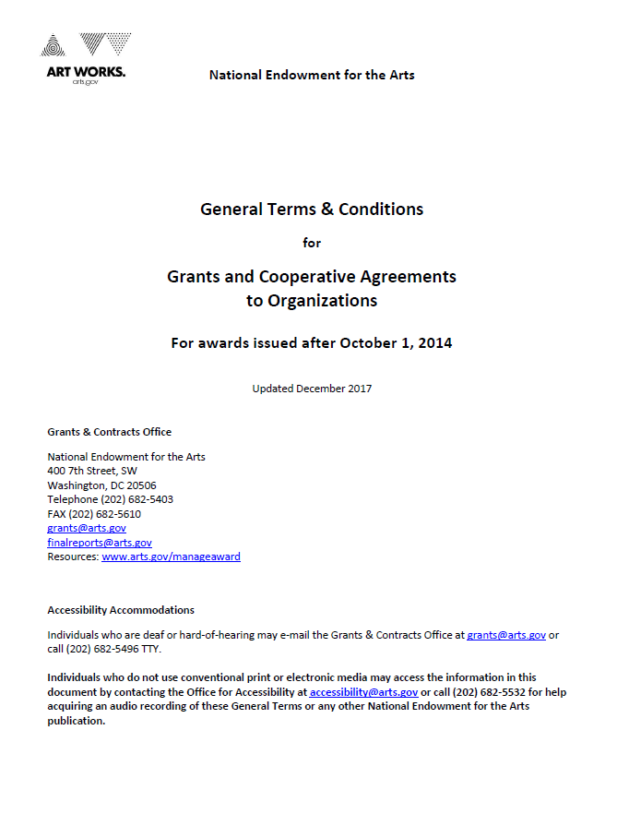

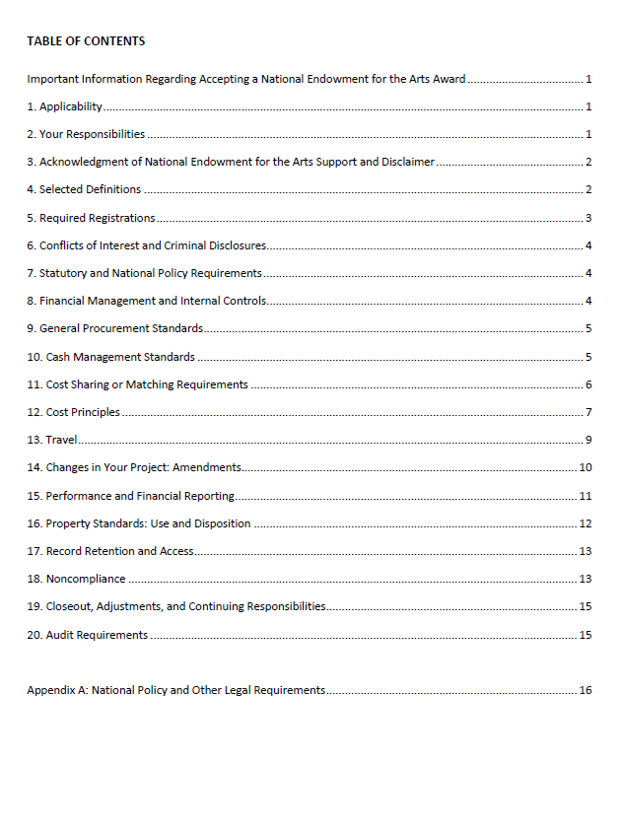

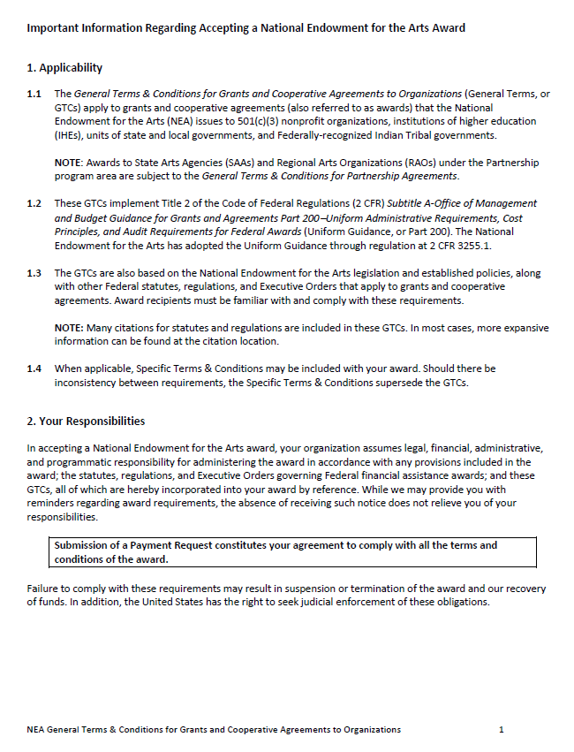

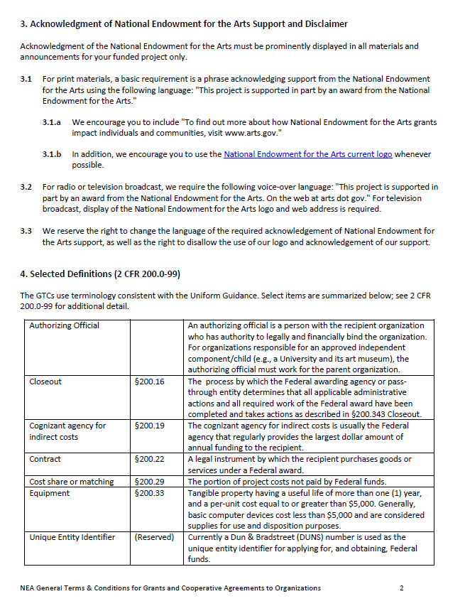

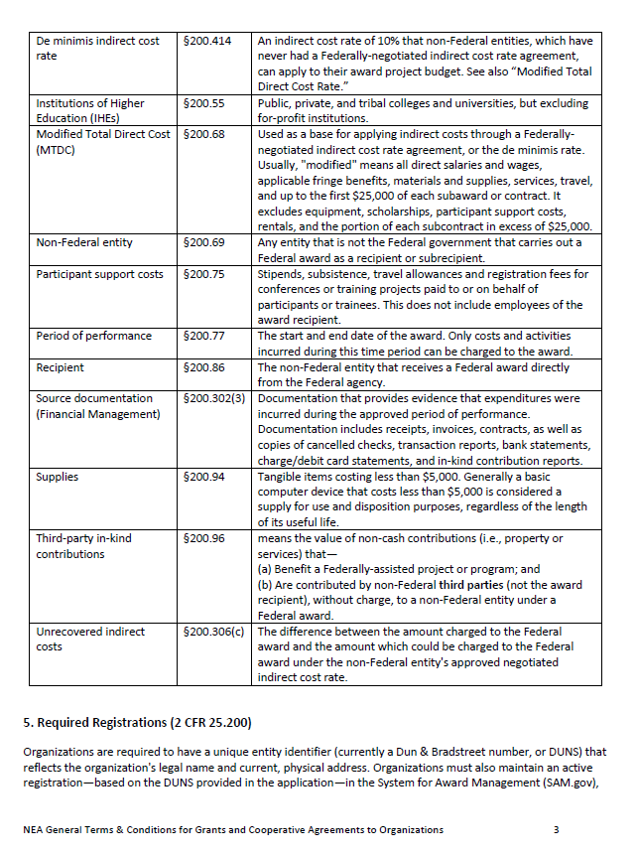

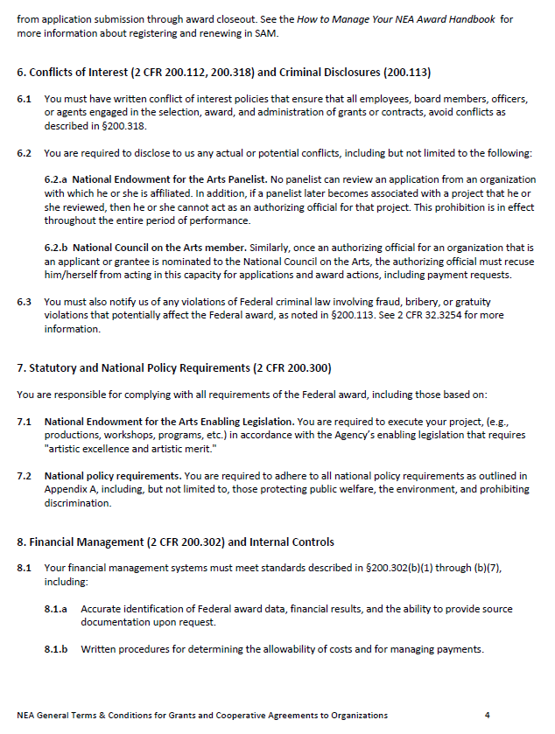

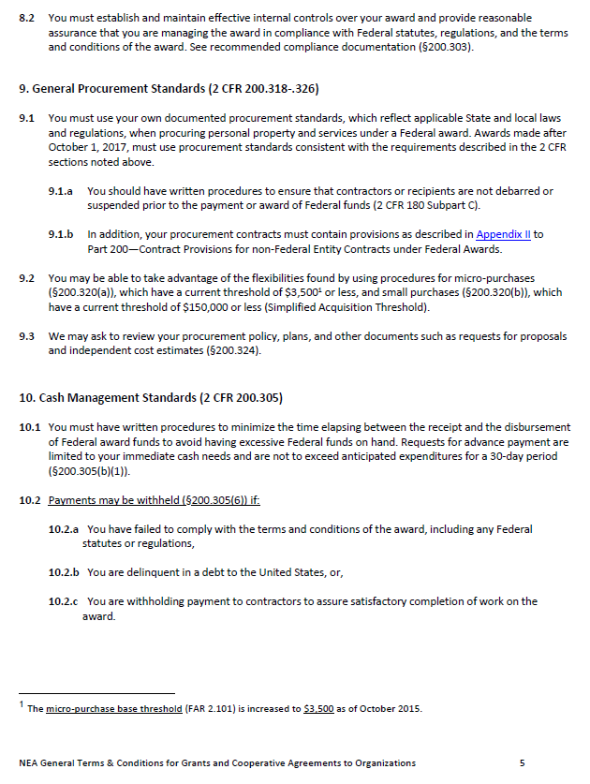

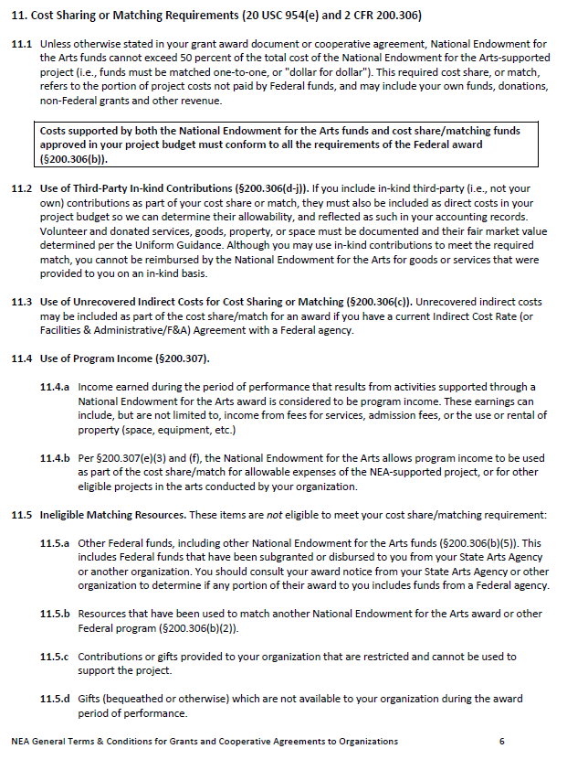

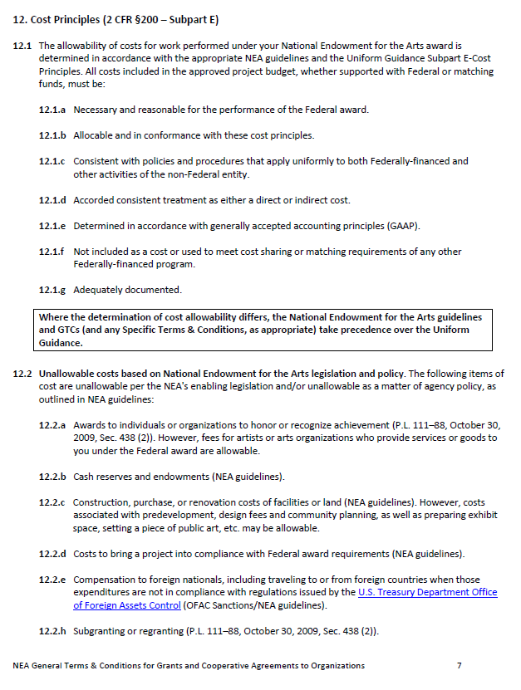

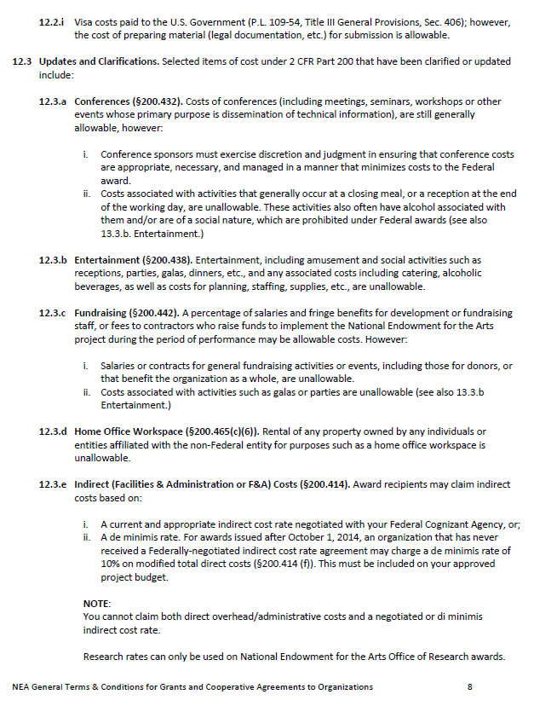

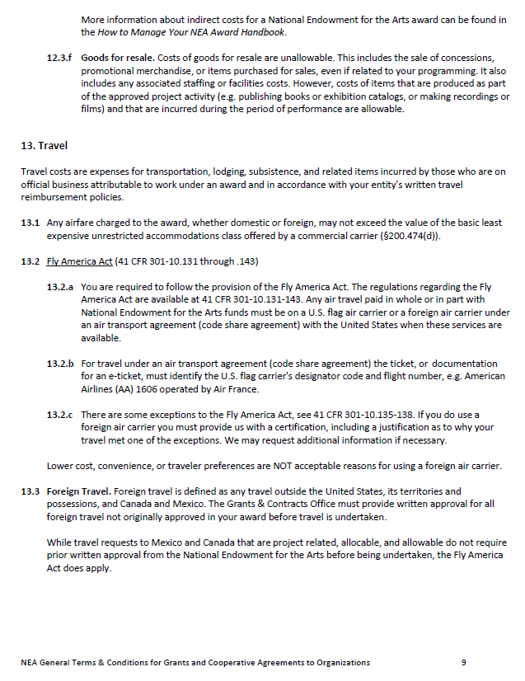

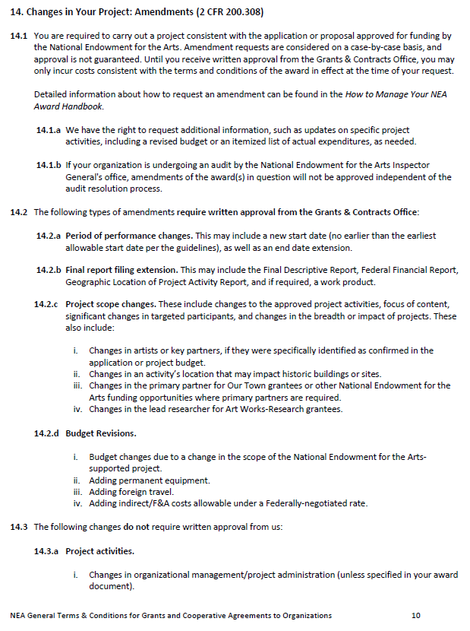

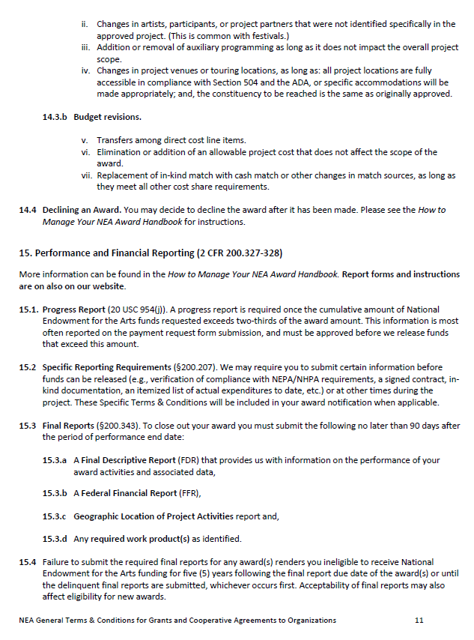

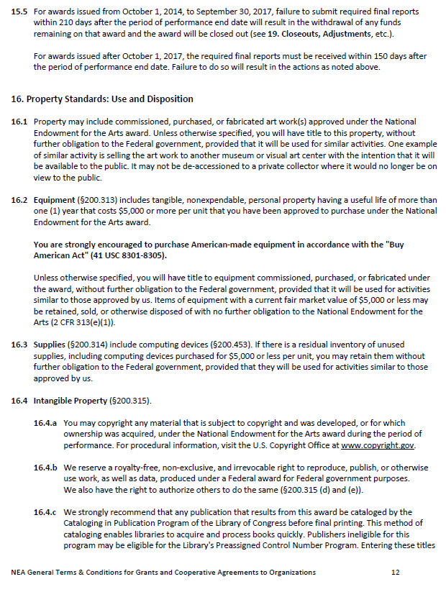

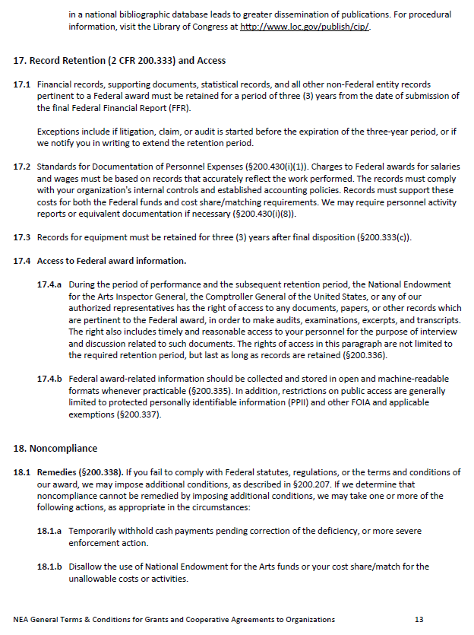

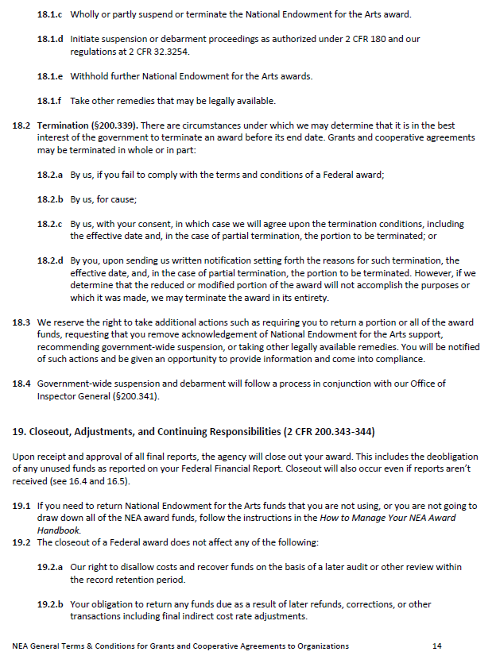

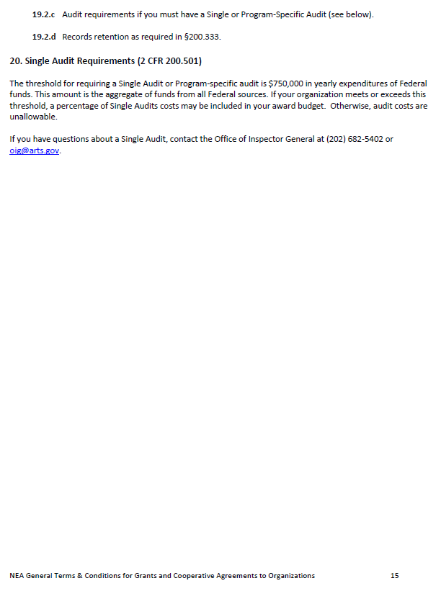

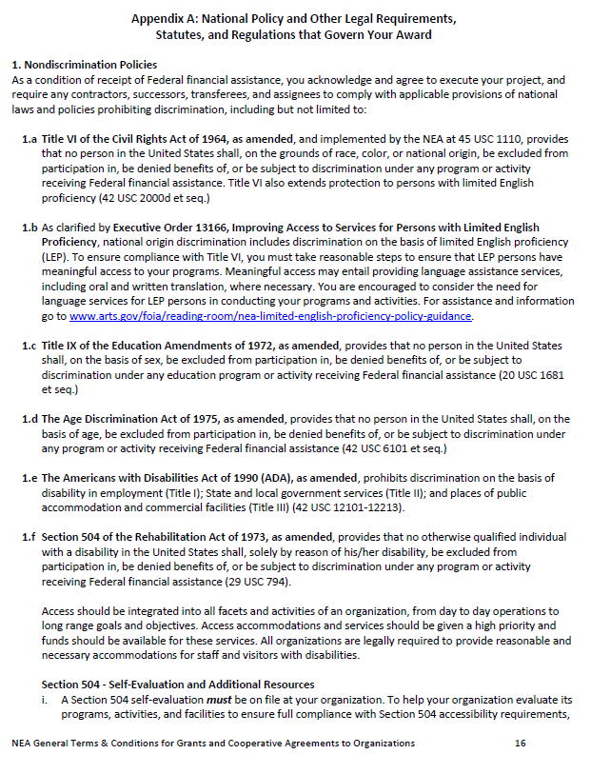

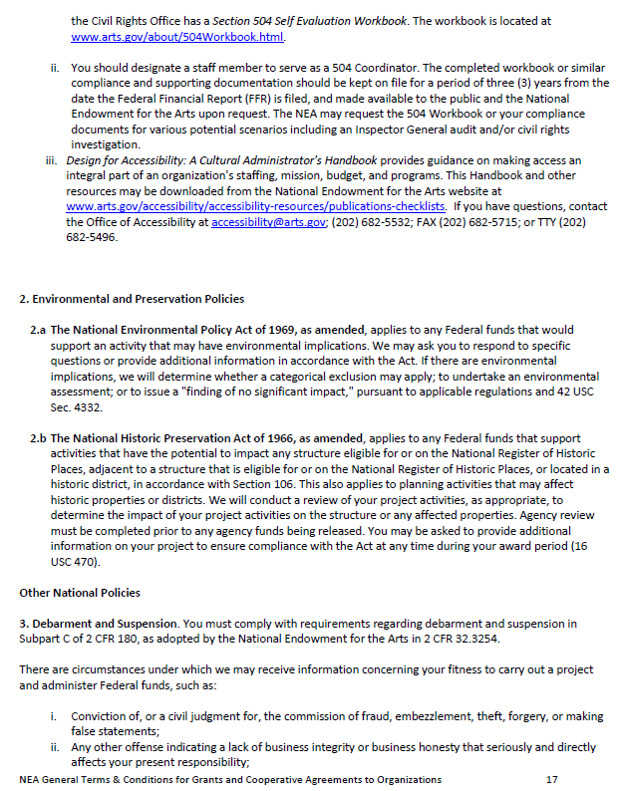

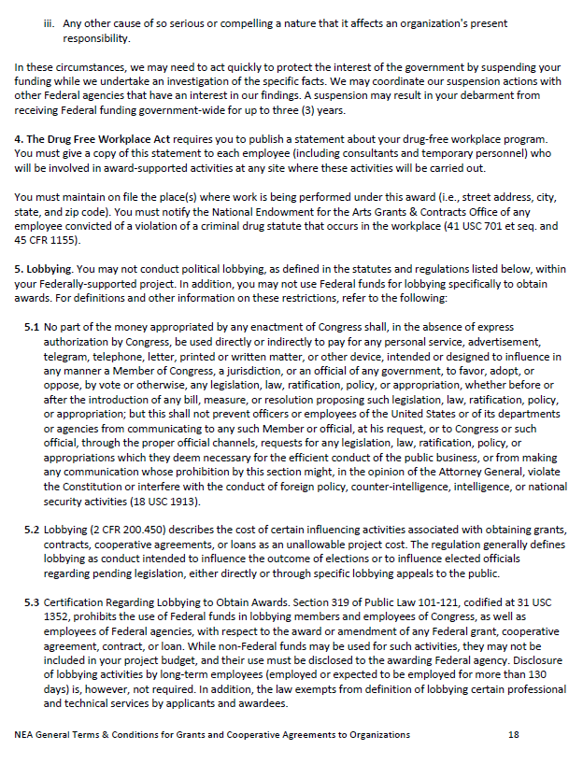

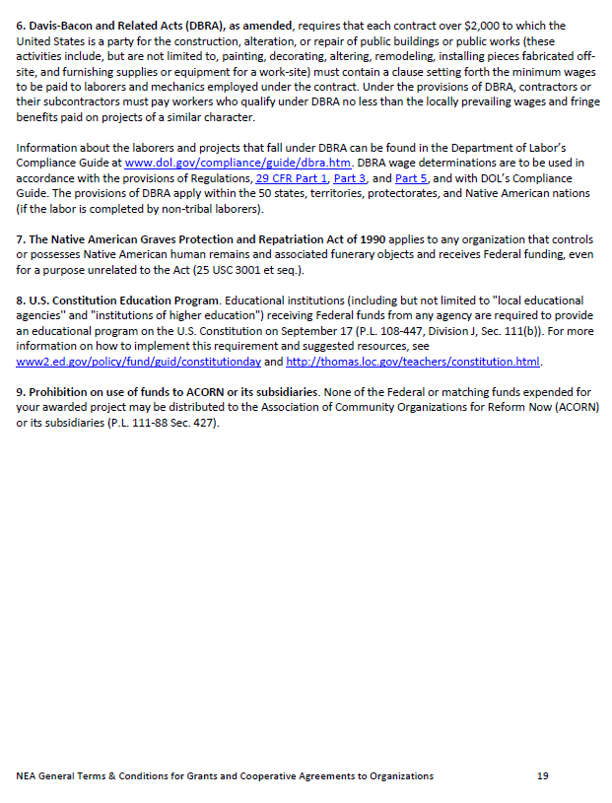

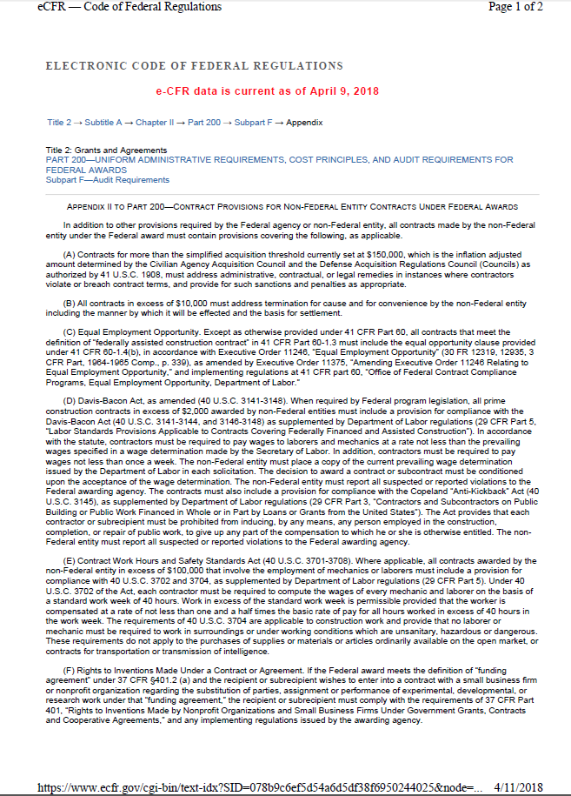

Attachment B

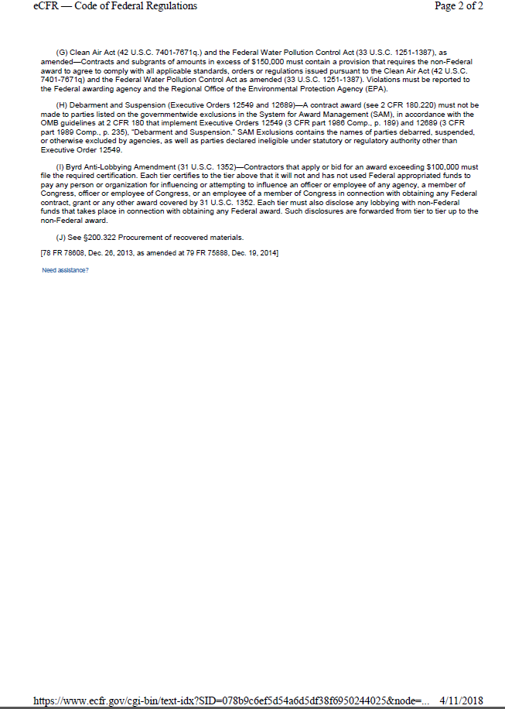

Attachment C

CONTRACTING WITH SMALL MINORITY BUSINESSES, WOMEN’S BUSINESS ENTERPRISES, AND LABOR SURPLUS AREA FIRMS

The City of Key West encourages the use of small minority businesses, women’s business enterprises, and labor surplus area firms. As a Consultant for the City, you are required to follow the affirmative steps below to assure that minority businesses, women’s business enterprises, and labor surplus area firms are used when possible:

      - Place qualified small and minority businesses and women’s business enterprises on solicitation lists.
      - Assure that small and minority businesses, and women’s business enterprises are solicited whenever they are potential sources.
      - Divide total requirements, when economically feasible, into smaller tasks or quantities to permit maximum participation by small and minority businesses, and women’s business enterprises.
      - Establish delivery schedules, where the requirement permits, which encourage participation by small and minority businesses, and women’s business enterprises.
      - Use the services and assistance, as appropriate, of such organizations as the Small Business Administration and the Minority Business Development Agency of the Department of Commerce.
      - Require the prime contractor/consultant, if subcontracts are to be let, to take the affirmative steps listed above.

Attachment D

CERTIFICATIONS AND ASSURANCES

In performance of this Contract, Consultant provides the following certifications and assurances:

1. Nondiscrimination Policies

2. Environmental and Preservation Policies

3. Debarment and Suspension

4. The Drug Free Workplace Act

5. Lobbying

6. Davis-Bacon and Related Acts (DBRA), as amended – CONSTRUCTION ONLY

7. Native American Graves Protection and Repatriation Act of 1990

8. U.S. Constitution Education Program

9. Prohibition on use of funds to ACORN or its subsidiaries

10. Conflicts of Interest and Criminal Disclosures

11. Unallowable Costs

12. Travel

13. Record Retention and Access

- NONDISCRIMINATION POLICIES
As a condition of this Federally funded project, you acknowledge and agree to perform work on the project as detailed in the Request for Proposals, and require any subcontractors, successors, transferees, and assignees to comply with applicable provisions of national laws and policies prohibiting discrimination, including but not limited to: Title VI of the Civil Rights Act of 1964 (as amended), Executive Order 13166 Improving Access to Services for Persons with Limited English Proficiency, Title IX of the Education Amendments of 1972 (as amended), The Age Discrimination Act of 1975 (as amended), The Americans with Disabilities Act of 1990 (ADA, as amended), Section 504 of the Rehabilitation Act of 1973 (as amended).

- ENVIRONMENTAL AND PRESERVATION POLICIES
The undersigned Consultant acknowledges that the following policies apply to this project:

2.a The National Environmental Policy Act of 1969, as amended, applies to any Federal funds that would support an activity that may have environmental implications.

2.b The National Historic Preservation Act of 1966, as amended, applies to any Federal funds that support activities that have the potential to impact any structure eligible for or on the National Register of Historic Places, adjacent to a structure that is eligible for or on the National Register of Historic Places, or located in a historic district, in accordance with Section 106. This also applies to planning activities that may affect historic properties or districts.

3. DEBARMENT AND SUSPENSION
The undersigned Consultant certifies to the best of its knowledge and belief, that it and its principals:

- Are not presently debarred, suspended, proposed for debarment, declared ineligible, or voluntarily excluded from covered transactions by a Federal department or agency;

- Have not within a three-year period preceding this Contract been convicted of or had a civil judgment rendered against them for commission of fraud or a criminal offense in connection with obtaining, attempting to obtain, or performing a public (Federal, State, or local) transaction or contract under a public transaction; violation of Federal or State antitrust statutes or commission of embezzlement, theft, forgery, bribery, falsification or destruction of records, making false statements, or receiving stolen property;

- Are not presently indicted or otherwise criminally or civilly charged by a government entity (Federal, State or local) with commission of any of the offenses enumerated in paragraph A.2. of this certification; and/or

- Have not within a three-year period preceding this application/proposal had one or more public transactions (Federal, State, or local) terminated for cause of default.

If Consultant is unable to certify to any of the statements in this certification, Consultant shall attach an explanation to this Contract.

4. CERTIFICATION REGARDING DRUG-FREE WORKPLACE REQUIREMENTS
Pursuant to the Drug-Free Workplace Act of 1988, the undersigned attests and certifies that the Consultant (if not an individual) will provide a drug-free workplace by the following actions:

1. Publishing a statement notifying employees, including temporary personnel, that the unlawful manufacture, distribution, dispensing, possession or use of a controlled substance is prohibited in the workplace and specifying the actions that will be taken against employees for violation of such prohibition.

2. Establishing an ongoing drug-free awareness program to inform employees concerning:
a. The dangers of drug abuse in the workplace.
b. The policy of maintaining a drug-free workplace.
c. Any available drug counseling, rehabilitation and employee assistance programs.
d. The penalties that may be imposed upon employees for drug abuse violations occurring in the workplace.

3. Making it a requirement that each employee to be engaged in the performance of the Contract be given a copy of the statement required by paragraph 4.1. of this certification.

4. Notifying the employee in the statement required by paragraph 4.1. of this certification that, as a condition of employment under the Contract, the employee will:
a. Abide by the terms of the statement.
b. Notify the employer in writing of his or her conviction for a violation of a criminal drug statute occurring in the workplace no later than five (5) calendar days after such conviction.

5. Notifying the City in writing ten (10) calendar days after receiving notice under subparagraph 4.b. from an employee or otherwise receiving actual notice of such conviction. Provide such notice of convicted employees, including position title, to every Contract Manager on whose contract activity the convicted employee was working. The notice shall include the identification number(s) of each affected Contract or Grant.

6. Taking one of the following actions, within thirty (30) calendar days of receiving
notice under subparagraph 4.4.b. herein, with respect to any employee who is so convicted:
a. Taking appropriate personnel action against such an employee, up to and including termination, consistent with the requirements of the Rehabilitation Act of 1973 as amended.
b. Requiring such employee to participate satisfactorily in drug abuse assistance or rehabilitation program approved for such purposes by a Federal, State or local, health, law enforcement, or other appropriate agency.

7. Making a good faith effort to continue to maintain a drug-free workplace through implementation of this entire certification.

If the Consultant is an individual, the Consultant certifies that:

- As a condition of the Contract, Consultant will not engage in the unlawful manufacture, distribution, dispensing, possession, or use of a controlled substance in conducting any activity with the contract; and,

- If convicted of a criminal drug offense resulting from a violation occurring during the conduct of any contract activity, Consultant will report the conviction, in writing, within 10 calendar days of the conviction, to the City when notice is made to such a central point, it shall include the identification number(s) of each affected contract.

5. CERTIFICATION REGARDING LOBBYING - Certification for Contracts, Grants, Loans and Cooperative Agreements.

The undersigned Consultant certifies, to the best of his or her knowledge and belief, that:
No Federal appropriated funds have been paid or will be paid, by or on behalf of the undersigned, to any person for influencing or attempting to influence an officer or employee of Congress, or an employee of a Member of Congress in connection with the awarding of any Federal contract, the making of any Federal grant, the making of any Federal loan, the entering into of any cooperative agreement, and the extension, continuation, renewal, amendment or modification of any Federal contract, grant, loan or cooperative agreement.

If any funds other than Federal appropriated funds have been paid or will be paid to any person for influencing or attempting to influence an officer or employee of any agency, a Member of Congress, an officer or employees of Congress, or employee of a Member of Congress in connection with a Federal contract, grant, loan, or cooperative agreement, the undersigned shall also complete and submit Standard Form - LLL, "Disclosure Form to Report Lobbying," in accordance with its instructions.

The undersigned shall require that language of this certification be included in the documents for all subcontracts at all tiers (including subcontracts, sub-grants and contracts under grants, loans and cooperative agreements) and that all sub-recipients and consultants shall certify and disclose accordingly.

This certification is a material representation of fact upon which reliance was placed when this Contract was made or entered into. Submission of this certification is a prerequisite for making or entering into this Contract imposed by 31 U.S.C. 1352. Any person who fails to file the required certification shall be subject to a civil penalty of not less than $10,000 and not more than $100,000 for each such failure.

6. DAVIS-BACON AND RELATED ACTS (DBRA), AS AMENDED
Applicable to construction contracts only.

7. THE NATIVE AMERICAN GRAVES PROTECTION AND REPATRIATION ACT OF 1990
The undersigned Consultant acknowledges the Native American Graves Protection and Repatriation Act applies to any organization that controls or possesses Native American human remains and associated funerary objects and receives Federal funding, even for a purpose unrelated to the Act (25 USC 3001 et seq.).

8. U.S. CONSTITUTION EDUCATION PROGRAM
The undersigned Consultant acknowledges that Educational institutions (including but not limited to "local educational agencies'' and "institutions of higher education") receiving Federal funds from any agency are required to provide an educational program on the U.S. Constitution on September 17 (P.L. 108-447, Division J, Sec. 111(b)). For more information on how to implement this requirement and suggested resources, see www2.ed.gov/policy/fund/guid/constitutionday and http://thomas.loc.gov/teachers/constitution.html.

9. PROHIBITION ON USE OF FUNDS TO ACORN OR ITS SUBSIDIARIES
The undersigned Consultant certifies that no Federal funds have been distributed to the Association of Community Organizations for Reform Now (ACORN) or its subsidiaries (P.L. 111-88 Sec. 427)

10. CONFLICTS OF INTEREST (2 CFR 200.112, 200.318) AND CRIMINAL DISCLOSURES (200.113)
The undersigned Consultant acknowledges the following apply to the City:

1. Written conflict of interest policies that ensure that all employees, board members, officers, or agents engaged in the selection, award, and administration of grants or contracts, avoid conflicts as described in §200.318.

2. Disclose to grantor any actual or potential conflicts, including but not limited to the following:

2.a National Endowment for the Arts Panelist. No panelist can review an application from an organization with which he or she is affiliated. In addition, if a panelist later becomes associated with a project that he or she reviewed, then he or she cannot act as an authorizing official for that project. This prohibition is in effect throughout the entire period of performance.

2.b National Council on the Arts member. Similarly, once an authorizing official for an organization that is an applicant or grantee is nominated to the National Council on the Arts, the authorizing official must recuse him/herself from acting in this capacity for applications and award actions, including payment requests.

3. Notify the grantor of any violations of Federal criminal law involving fraud, bribery, or gratuity violations that potentially affect the Federal award, as noted in §200.113. See 2 CFR 32.3254 for more information.

11. UNALLOWABLE COSTS
The undersigned Consultant certifies the National Endowment for the Arts’ unallowable costs have been reviewed. Refer to National Endowment for the Arts General Terms & Conditions (December 2017 version), Section 12.2, page 7 which can be found in this RFP, Attachment A.

12. TRAVEL
The undersigned Consultant certifies the National Endowment for the Arts’ travel information has been reviewed. Refer to National Endowment for the Arts General Terms & Conditions (December 2017 version), Section 13, page 9 which can be found in this RFP, Attachment A.

13. RECORD RETENTION AND ACCESS
The undersigned Consultant acknowledges the record retention period of three (3) years. Financial records, supporting documents, statistical records, and all other records pertinent to this project must be retained for a period of three (3) years from the date of submission of the City’s final Federal Financial Report (FFR).

Exceptions include if litigation, claim, or audit is started before the expiration of the three-year period, or if the City provides notification in writing to extend the retention period.

If Consultant is unable to certify to any of the statements in this certification, Consultant shall attach an explanation to this Contract.

By signing below, Consultant certifies the representations outlined in parts 1 through 13 above are true and correct.

(Signature and Title of Authorized Representative)

Consultant Name

Consultant Street Address

City, State, ZIP Code

PART 5

DRAFT AGREEMENT

Consulting Agreement

This AGREEMENT is made and entered into this ___ day of ________, 2018, by and between the City of Key West, Florida, a municipal corporation of the State of Florida, whose address is P.O Box 1409, Key West, Florida 33041, hereafter referred to as the "CITY" and , whose address is , hereafter referred to as the "CONSULTANT". This agreement shall be effective on the date of execution of the last party to sign the AGREEMENT for the term specified in Paragraph 6.1.

Article 1. Scope of Services
Attached hereto, incorporated by reference, and more particularly described as “Exhibit A” is the City’s Request for Proposals #009-18 and CONSULTANT’S proposal dated , and NEA Grant requirements including Attachments A, B, C and D (signed), which are attached hereto, incorporated by reference, and more particularly described as “Exhibit B.” The Task Breakdown contains a list of activities corresponding to each category/series referred to herein above.

The CONSULTANT’S primary responsibilities include, but are not limited to, assisting the City with developing a Truman Waterfront Arts & Culture Master Plan that includes creative placemaking to strengthen the community and connect Key West’s Historic Old Town and the waterfront park area as a community place to gather (the “Project”). Additional work may include other consulting services which the CONSULTANT is qualified to provide and which the CITY authorizes the CONSULTANT to undertake in connection with the CITY’s present and planned activities in the areas identified below. The specific task goals, task activities and key project milestones, which the CONSULTANT agrees to undertake, accomplish and furnish, are set forth as follows:

- Scope of Work
Task A Project Administration - Refining the scope, and ongoing project management.
Implement the NEA Our Town grant as described herein. Consultant will work with City Staff and all other partners listed, in soliciting the public’s input and create and manage the process to create an Arts & Culture Master Plan for Truman Waterfront.

A.1 - Finalize Scope, Budget and Timeline
The consultant will, in consultation with the City’s Public Art Administrator, Florida Keys Council of the Arts (FKCA), modify the timeline to include partner meetings, specific public engagement efforts, website launch, EcoArt workshop, and other milestones as needed for the project’s success. Minor modifications of the scope and budget may or may not be allowed at this point.

A.2 – Stakeholder Kick Off Meeting
The consultant will organize and hold a kick off meeting with all partners and stakeholders.

A.3 – Ongoing Project Management
The Consultant will:
- The consultant will monitor work progress, budget, assign staff, oversee technical work and implement quality control.
- Provide as-needed project coordination conference calls and/or meetings between the Public Art Administrator, Partners and City Staff.
- Provide progress reports monthly to the Public Art Administrator.
- Provide invoices to the Public Art Administrator as Tasks are completed.
- Prepare all meeting agendas and materials, distributing these to the City Project Manager at least 48 hours in advance.
- Provide a project website and social media presence.
- Create and maintain a database of stakeholders and participants
- Administer stipends to Park Arts Vision Team and Cultural Partner Groups at end of project.

Deliverables:
- Updated Scope of Work and Timeline
- Project Website
- First progress report

Milestone Payment: $10,000

Task B Implement Public Engagement and Needs Assessment Process
The intent of this Task is to gather input through public engagement, in order to assess what the community needs are and build consensus. The format and documentation of this process is important, because although focused on the Truman Waterfront Park, needs to be replicable throughout the City of Key West for other arts and cultural projects. To be statistically significant at a 90% confidence level, the Consultant needs to get input from at least 100 residents and 50 tourists. The City prefers the Consultant strive to reach the 95% confidence level, needing input from 400 residents and 200 tourists.

The Process should include, but not be limited to:
- Transparent outcomes.
- Straightforward and easily replicable steps.
- Community workshops in neighborhoods to engage residents/part-time residents
- Outreach to tourists and Keys residents that live outside City boundaries.
- Under-represented populations, including those working multiple jobs who find it difficult to attend meetings.
- Interviews with key stakeholders
- Innovative and non-traditional outreach and public involvement is also desired.

Deliverables:
- Placemaking Public Engagement and Needs Assessment Process Report
- Raw data gathered from this Task.

Milestone Payment: $20,000

Task C EcoArt Workshop
The Consultant, in partnership with City Sustainability Coordinator, will design and host an Eco art workshop, orienting community members, officials, design professionals to a design approach addressing environmental challenges. Focus will involve both art that has a function and green infrastructure that is aesthetically pleasing. Workshop will include a 10-15 person field trip to South Florida to see concepts in real life.

Deliverables:
- Summary of EcoArt Workshop
- Participants’ Review / Comments

Milestone Payment: $12,000

Task D Truman Waterfront Park Arts & Culture Master Plan
The Arts & Culture Master Plan will summarize the engagement process and resulting community needs by target audiences. It will include overall purpose and guidance, public art selection process, partners & performance opportunities for the Amphitheater & Folk-Art Community Garden/Market, EcoArt design concepts, economic impact, overall budget and marketing plan.

Completion of the Plan will include at least one final public workshop and a presentation to a joint meeting of the Truman Waterfront Advisory Board and Art In Public Places Board.

Deliverables:
- Truman Waterfront Park Arts & Cultural Master Plan

Milestone Payment: $30,000

Task E Public Art & Performance Demonstration Projects
The Consultant shall advise the City’s Public Art Administrator in the bidding and procurement of at least $50,000 worth of art and cultural installations, with a completion date of March 15th, 2019.

Deliverables:
- Public Art Installations
- Ribbon Cutting and cultural demonstration for public art and NEA grant completion

Milestone Payment: $3,000

Article 2. Compensation
As consideration for providing the services enumerated in Article 1, the CITY shall pay the CONSULTANT as follows:

- The City anticipates work to be performed through Scope of Service Tasks with payment for services on a per Task lump sum milestone payment/not-to-exceed as detailed in the below schedule. The City reserves the right to negotiate a compensation package that is fair and reasonable to the City, as determined solely by City. All costs including travel are to be included. The City will not accept any additional costs.

Task | Description | Milestone Payment
A | Project Administration | $ 10,000
B | Public Engagement | $ 20,000
C | EcoArt Workshop | $ 12,000
D | Truman Waterfront Arts & Culture Master Plan | $ 30,000
E | Public Art Performance | $ 3,000
 | TOTAL AWARD: | $ 75,000

Article 3. Invoicing and Payment

Consultant invoices including expenses will be submitted monthly and are payable upon receipt. Invoices amounts not received within 30 days from receipt are considered past due and subject to interest.

Article 4. Obligations of the Consultant

4.1. General
- The CONSULTANT will serve as CITY’S professional representative under this AGREEMENT, assisting the City with certain enumerated aspects of developing a Truman Waterfront Arts & Culture Master Plan (the “Project”).

4.2. Standard of Care
- The standard of care applicable to CONSULTANT’S services will be the degree of skill and diligence normally employed by professionals and other related consultants performing the same or similar services at the time said services are performed. The CONSULTANT will perform any services not meeting this standard without additional compensation.

4.3 CONSULTANT’S Insurance
The CONSULTANT will maintain throughout this AGREEMENT the following insurance:
- Worker's Compensation – Statutory – in compliance with the Compensation law of the State of Florida. In addition, the Consultant shall obtain Employers’ Liability Insurance with limits of not less than:
  - Five Hundred Thousand ($500,000.00) Dollars Bodily Injury by Accident
  - Five Hundred Thousand ($500,000.00) Dollars Bodily Injury by Disease, Policy Limits
  - Five Hundred Thousand ($500,000.00) Dollars Bodily Injury by Disease, each employee

- Commercial General Liability including but not limited to bodily injury, property damage, contractual liability, products and completed operations (without limitation) and no more restrictive than ISO form CG 20 37 (07 04) shall be in an amount acceptable to the City of Key West but not less than One Million ($1,000,000.00) Dollars Combined Single Limit per occurrence. The coverage must include:
- Commercial Form
- Premises/Operations
- Products/Completed Operations
- Independent Consultants (if any part of the Work is to be subcontracted)
- Broad Form Property Damage
- Personal Injury

- Business Automobile Liability Insurance with a minimum limit of liability of One Million ($1,000,000.00) Dollars each occurrence covering all worked performed under this contract. This insurance shall include for bodily injury and property damage the following coverage:
- Owned automobiles
  - Hired automobiles
  - Non-owned automobiles
  - Location of operation shall be “All Locations”
In the event Consultant does not own automobiles, Consultant agrees to maintain coverage for Hired & Non-Owned Auto Liability, which may be satisfied by way of endorsement to the Commercial General Liability policy or separate Business Auto Liability policy. If private passenger automobiles are used in the business, they must be commercially insured.

- Professional Liability/Errors & Omissions Insurance with minimum limits not less than One Million ($1,000,000.00) Dollars for professional services rendered in accordance with this contract. The Consultant shall maintain such insurance for at least two (2) years from the termination of this contract and during this two (2) year period the Consultant shall use his/her best efforts to ensure that there is no change of the retroactive date on this insurance coverage. If there is a change that reduces or restricts the coverage carried during the contract, the Consultant shall notify City Risk Management within thirty (30) days of the change.

- Scope of Insurance and Special Hazards
The insurance requirement contained in the foregoing Paragraphs are a minimum to provide adequate protection for the Consultant, respectively, against damage claims which may arise from operations under this contract, whether such operation be by the insured or by anyone directly or indirectly employed by the insured and, also against any of the special hazards which may be encountered in the entity’s operation under this contract. The insurance required herein and approval of the Consultant’s insurance by the City of Key West shall not relieve or decrease the liability of the Consultant hereunder.

Insurance requirements itemized in this contract and required of the Consultant shall be provided on behalf of all sub-contractors to cover their operations performed under this contract. The Consultant shall be held responsible for any modifications, deviations, or omissions in these insurance requirements as they apply to sub-contractors.

- Certificates of Insurance
Certificates of Insurance shall be filed and maintained throughout the life of any resulting Agreement with the City of Key West, P.O. Box 1409, Key West, FL 33041-1409 evidencing the minimum limits of the insurance cited above prior to commencement of work. All insurance certificates shall be received by City Clerk and Department of Risk Management before Consultant will be allowed to commence or continue work (all insurance carriers must have their corresponding AM Best carrier ID listed on the COI). All policies shall provide that they may not be terminated or modified without the insurer providing the City of Key West at least thirty (30) days of advance notice. Additionally, the Consultant shall immediately notify the City of any cancellation of such insurance. The City of Key West reserves the right to review, at any time, coverage, form, and amount of insurance. CITY will be named as additional insured on all policies – excepting Professional Liability and Workers’ Compensation – on a primary and noncontributory basis utilizing an ISO standard endorsement.

In addition, it is understood if at any time any of the policies required by City shall become unsatisfactory to the City as to form or substance, or if a company issuing any such policy shall become unsatisfactory to the City, the Consultant shall obtain a new policy, submit the same to the City for approval and submit a certificate of insurance as which may be required by the contract. It is understood that upon failure of the Consultant to furnish, deliver and maintain such insurance as above provided, the contract at the election of the City may be declared suspended, discontinued or terminated. Further, failure of the Consultant to take out and/or maintain any required insurance shall not relieve the Consultant from any liability under the contract, nor shall the insurance requirements be construed to conflict with the obligations of the Consultant concerning indemnification.

4.4 Subconsultants
- The CONSULTANT may not assign or subcontract its obligations under this AGREEMENT without the written consent of the CITY’s Project Manager.

B. The CONSULTANT is as fully responsible to the owner for the acts and omissions of his Subconsultants and of persons either directly or indirectly employed by them as he is for the acts and omissions of persons directly employed by him.

C. Nothing contained in the Contract Documents shall create any contractual relationship between any Subconsultant and the City. The Subconsultants shall have the same insurance requirements as the CONSULTANT.

Article 5. Obligations of the City
5.1. Authorization to Proceed
Authorization to proceed will be considered to be given upon execution of this Agreement by CITY.

5.2. City-Furnished Data
Subject to the confidentiality requirements pursuant to state and federal law, including those contained in the Federal Privacy Act of 1974, the CITY will provide to the CONSULTANT all data in the CITY’S possession relating to the CONSULTANT’s services on the PROJECT including, but not limited to, information on any pre-existing reports. CONSULTANT will reasonably rely upon the accuracy, timeliness, and completeness of the information provided by the CITY.

5.3. Access to Facilities and Property
The CITY will make its facilities accessible to CONSULTANT as required for CONSULTANT’s performance of its services and will provide labor and safety equipment as required by CONSULTANT for such access. CITY will be responsible for all acts of CITY’S personnel.

5.4. Timely Review
The CITY will examine the CONSULTANT’s studies, reports, and other documents; obtain advice of an attorney, insurance counselor, accountant, auditor, bond and financial advisors, and other consultants as CITY deems appropriate; and render in writing decisions required of CITY in a timely manner.

5.5. Prompt Notice
The CITY will give prompt written notice to CONSULTANT whenever CITY observes or becomes aware of any development that affects the scope or timing of CONSULTANT’s services, or any defect in the work of the CONSULTANT.

5.6 Litigation Assistance
The Scope of Services does not include costs of CONSULTANT for required or requested assistance to support, prepare, document, bring, defend, or assist in litigation undertaken or defended by CITY. All such services required or requested of CONSULTANT by CITY, except for suits or claims between the parties to this AGREEMENT, will be reimbursed as mutually agreed in a separate agreement.

Article 6. General Legal Provisions

6.1 Agreement Period
The duration of the Agreement shall be one year commencing from the effective date of this Agreement.

6.2. Reuse of Project Documents
Reports, documents and other deliverables of the CONSULTANT, whether in hard copy or in electronic form, are instruments of service for the project of the CITY and are the property of the City of Key West. Reuse, change, or alteration on another project, by the CITY or by others acting on behalf of the CITY of any such instruments of service without the written permission of the CONSULTANT will be at the CITY's sole risk. Nothing herein shall constitute a waiver of City’s sovereign immunity rights, including, but not limited to, those expressed in Section 768.28, Florida Statutes.
6.3 Ownership of Work Product and Inventions
All of the work product provided by the CONSULTANT to the City in furtherance of this Agreement shall become the property of the CITY.

6.4 Force Majeure
A. The CONSULTANT is not responsible for damages or delay in performance caused by acts of God, strikes, lockouts, accidents, or other events beyond the control of the CONSULTANT.
B. In the event of a delay that results in additional costs to the CONSULTANT, an appropriate increase in compensation and schedule will be authorized in writing.

6.5 Termination
- This agreement may be terminated at any time, with or without cause, by the CITY upon thirty (30) days written notice to CONSULTANT. No further work will be performed by CONSULTANT upon receipt of this notice unless specifically authorized by the General Services Department Director of the City of Key West.
- On termination, the CONSULTANT will be paid for all authorized services performed up to the termination date plus, if terminated for the convenience of the CITY, reasonable expenses incurred during the close-out of the AGREEMENT. The CITY will not pay for anticipatory profits.
- CONSULTANT may terminate this Agreement for cause. Termination for cause shall be by written “Termination Notice” from CONSULTANT and delivered to CITY. CITY shall have thirty (30) days from receipt of the Termination Notice within which to cure the alleged default, or if the cure requires a period of time in excess of thirty (30) days the cure period shall be extended by mutual agreement so long as CITY has undertaken such reasonably diligent efforts to cure such default.

6.6 Suspension, Delay, or Interruption of Work
The CITY may suspend, delay, or interrupt the services of the CONSULTANT for the convenience of the CITY. In the event of such suspension, delay, or interruption, or any other act or neglect of CITY or CITY's subcontractors, CITY will pay CONSULTANT for work performed to date. An equitable adjustment in the PROJECT’S schedule and CONSULTANT’s compensation will be made as agreed to by both parties.
6.7 Third Party Beneficiaries
This Agreement gives no rights or benefits to anyone other than the CITY and CONSULTANT and has no third party beneficiaries. CONSULTANT’s services are defined solely by this proposed scope of services, and not by any other contract or agreement that may be associated with the Project. All work products will be prepared for the exclusive use of CITY for specific application as described in the proposed scope of services. No warranty, expressed or implied, is made. There are no beneficiaries of the work products other than CITY, and no other person or entity is entitled to rely upon the work products without the written consent of CONSULTANT. Any unauthorized assignment of related work product shall be void and unenforceable.

6.8 Indemnification
A. To the fullest extent permitted by law, the CONSULTANT expressly agrees to indemnify and hold harmless the City of Key West, their officers, directors, agents and employees (herein called the “indemnitees”) from any and all liability for damages, including, if allowed by law, reasonable attorney’s fees and court costs, such legal expenses to include costs incurred in establishing the indemnification and other rights agreed to in this Paragraph, to persons or property, caused in whole or in part by any act, omission, or default by CONSULTANT or its subcontractors, material men, or agents of any tier or their employees, arising out of this agreement or its performance, including any such damages caused in whole or in part by any act, omission or default of any indemnitee, but specifically excluding any claims of, or damages against an indemnitee resulting from such indemnitee’s gross negligence, or the willful, wanton or intentional misconduct of such indemnitee or for statutory violation or punitive damages except and to the extent the statutory violation or punitive damages are caused by or result from the acts or omissions of the CONSULTANT or its subcontractors, material men or agents of any tier or their respective employees.
CONSULTANT hereby agrees to indemnify the City of Key West and each of its parent and subsidiary companies and the directors, officers and employees of each of them (collectively, the “indemnitees”), and hold each of the indemnitees harmless, against all losses, liabilities, penalties (civil or criminal), fines and expenses (including reasonable attorneys’ fees and expenses) (collectively, “Claims”) to the extent resulting from the performance of CONSULTANT negligent acts, errors or omissions, or intentional acts in the performance of CONSULTANT services, or any of their respective affiliates, under this Agreement. If claims, losses, damages, and judgments are found to be caused by the joint or concurrent negligence of the City of Key West and CONSULTANT, they shall be borne by each party in proportion to its negligence.

The indemnification obligations under this Agreement shall not be restricted in any way by any limitation on the amount or type of damages, compensation, or benefits payable by or for the CONSULTANT under Workers’ Compensation acts, disability benefits acts, or other employee benefits acts, and shall extend to and include any actions brought by or in the name of any employee of the CONSULTANT or of any third party to whom CONSULTANT may subcontract a part or all of the Work. This indemnification shall continue beyond the date of completion of work.

Nothing in this indemnification is intended to act as a waiver of the City’s sovereign immunity rights, including those provided under section 768.28, Florida Statues

B. This indemnification shall survive the expiration or termination of this Agreement. In the event that any action or proceeding is brought against the CITY by reason of such claim or demand, CONSULTANT shall, upon written notice from the CITY, resist and defend such action or proceeding by counsel satisfactory to the CITY. The CONSULTANT shall defend at its own expense to and through appellate, supplemental or bankruptcy proceeding, or to provide for such defense, at the CITY’s option, any and all claims of liability and all suits and actions of every name and description covered above which may be brought against the CITY whether performed by CONSULTANT, or by persons employed or used by CONSULTANT.
C. In no event shall CONSULTANT, its affiliated corporations, officers, employees, or any of its subcontractors be liable for any incidental, indirect, special, punitive, economic or consequential damages, including but not limited to loss of revenue or profits, suffered or incurred by CITY or any of its agents, including other contractors engaged at the project site, as a result of this Agreement or CONSULTANT’s performance or non-performance of services pursuant to this Agreement. Limitations of liability provided in this paragraph apply whether the liability is claimed to arise in contract, tort (including negligence), strict liability, or otherwise.

6.9 Limitation of Liability
- CONSULTANT’s services shall be governed by the negligence standard for professional services, measured as of the time those services are performed.
- This Provision takes precedence over any conflicting Provision of this Agreement or any document incorporated into it or referenced by it.
- This limitation of liability will apply whether CONSULTANT’S liability arises under breach of contract or warranty; tort; including negligence; strict liability; statutory liability; or any other cause of action, and shall include CONSULTANT’s officers, affiliated corporations, employees, and subcontractors.

6.10 Assignment

Consultant shall not assign all or any part of this Agreement without the prior consent of the CITY by Resolution of the Key West City Commission.

6.11 Jurisdiction
The law of the state of Florida and Monroe County will govern the validity of this AGREEMENT, its interpretation and performance, and any other claims related to it.

6.12 Severability and Survival
- If any of the provisions contained in this AGREEMENT are held for any reason to be invalid, illegal, or unenforceable in any respect, such invalidity, illegality, or unenforceability will affect any other provision, and this AGREEMENT will be construed as if such invalid, illegal, or unenforceable provision had never been contained herein.
- ARTICLES 4 and 5 will survive termination of this AGREEMENT for any cause.

6.13 Dispute Resolution
- The parties will use their best efforts to resolve amicably any dispute, including the use of alternative dispute resolution options.
- Unless otherwise agreed in writing, the CONSULTANT shall continue the Work and maintain the approved schedules during any arbitration proceedings. If the CONSULTANT continues to perform, CITY shall continue to make payments in accordance with this Agreement.
6.14 Post Contractual Restriction
This Agreement is contingent upon the execution of Post Contractual Restrictions by Consultant, those subconsultants referred to in Article 4.4(B) above, and those subconsultants approved by the City pursuant to Article 4.4(A) above restricting those persons and entities, as well as the employees of those persons and entities, from representing themselves or clients before the City Commission of the City Key West, the City’s agents, boards, and committees on all planning related matters during the period of performance of this Agreement and for the period of one year following final approval of the Evaluation and Appraisal Report Amendments to the Comprehensive Plan. The Post Contractual Restrictions shall be executed simultaneously with this Agreement and shall be in a form acceptable to City.

6.15 Attorney’s Fees
In the event of litigation affecting the rights of either party under this Agreement, the losing party shall pay the prevailing party's costs, expenses, and Attorney's Fees incurred in the enforcement of the prevailing party's rights hereunder, including those pertaining to appeals.

6.16 Record Retention
CONSULTANT shall preserve and make available, at reasonable times for examination and audit by CITY and grant-related interests, all financial records, supporting documents, statistical records, and any other documents pertinent to this Agreement for the required retention period of the Florida Public Records Act (Chapter 119, Fla. Stat.), if applicable, or, if the Florida Public Records Act is not applicable, for a minimum period of three (3) years after termination of this Agreement. If any audit has been initiated and audit findings have not been resolved at the end of the retention period or three (3) years, whichever is longer, the books, records, and accounts shall be retained until resolution of the audit findings. If the Florida Public Records Act is determined by CITY to be applicable to CONSULTANT's records, CONSULTANT shall comply with all requirements thereof; however, no confidentiality or non-disclosure requirement of either federal or state law shall be violated by CONSULTANT. Any incomplete or incorrect entry in such books, records, and accounts shall be a basis for CITY’s disallowance and recovery of any payment upon such entry.

Article 7. Exhibit and Signatures
This AGREEMENT, including its Schedules and Exhibits, constitutes the entire AGREEMENT, supersedes all prior written or oral understandings, and may only be changed by a written amendment executed by both parties.

IN WITNESS WHEREOF, the parties execute below:
CITY OF KEY WEST, FLORIDA
By:
James K. Scholl, City Manager

ATTEST:

Dated this ______ day of ___________, 2018
Cheryl Smith, City Clerk

CONSULTANT’S COMPANY NAME

By: _____________________________
Consultant’s Representative

Dated this ______ day of ___________, 2018
Attachments:
Exhibit A – RFP #009-18
Exhibit B – Consultant’s Proposal

