Town of Huntington – Public Art Initiative
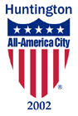
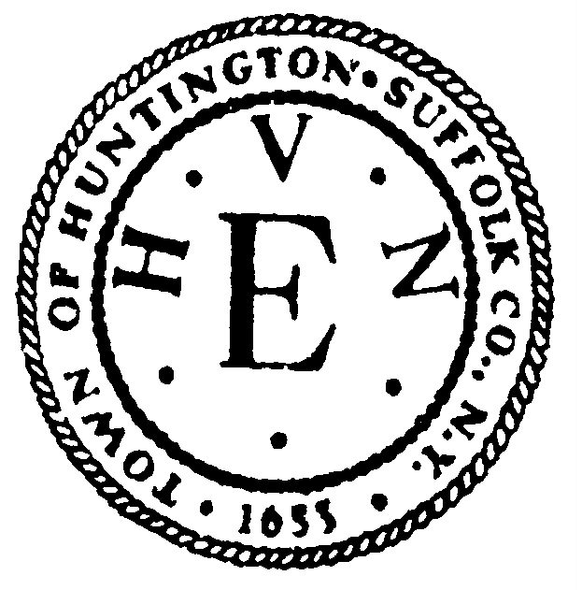

Request For Proposals

Traffic Signal Box Projects in Various Locations in Huntington
RFP # 2018-06-005
Submission Deadline: Friday, June 22, 2018

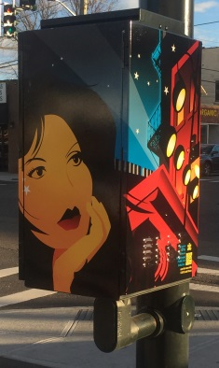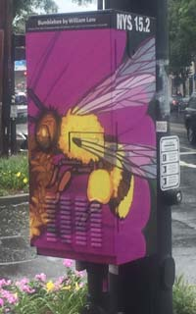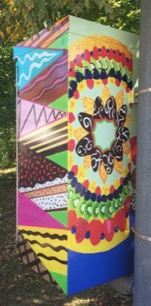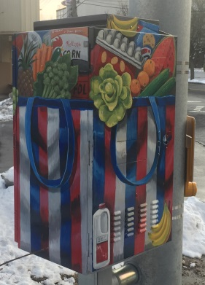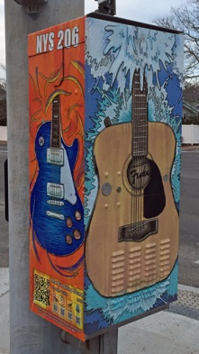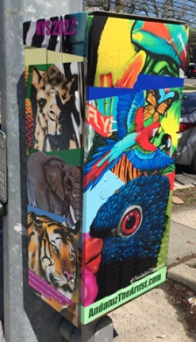

Open Call to Artists: With authorization from the Huntington Town Board the Huntington Public Art Advisory Committee is seeking submission of additional design proposals for artistic transformation of Traffic Signal Boxes in various locations in the Town of Huntington, including expansion of existing installations in Huntington Village and Huntington Station, as well as other potential locations to be determined. Appropriate proposals might include trompe l’oeil transformations of signal boxes into other objects, use of representational images to celebrate the community’s history or culture, or abstract or decorative proposals. Bold forms and vibrant colors that can be easily viewed by motorists stopped at the traffic signal, as well as by passing pedestrians are encouraged.

A small sampling of images from the 25 Signal Box projects already installed in Huntington Village and Huntington Station is pictured above; visit www.HuntingtonNY.gov/TrafficSignalBoxes for a complete listing. Design submissions in response to Signal Box project RFPs issued previously will still be considered for this new round of projects, but new proposals are now being sought to provide additional designs for consideration. Artists, photographers, or design professionals in the NY metropolitan area are eligible to respond to this RFP. Prior public art experience is NOT required.

Project Budget: Each Signal Box installation has an anticipated budget of up to $1,600, comprised of an artist design honorarium of $1,000 and a fabrication/installation budget of up to $600. Allocation of these separate portions of the project budget will vary depending upon the fabrication/installation method chosen by the artist (see below).

Nature of Traffic Signal Box Project: Each winning conceptual design proposal will be fabricated/installed using one of the following two methods, as indicated by the artist in their design proposal:
- Four-color process digital printing of the design on adhesive vinyl wrap to be applied to at least three (3) vertical exterior sides of the rectangular signal box. If this method is chosen, the selected artist will be responsible for providing to an outside vendor high-resolution digital images of the selected design formatted to match the precise dimensions of the assigned signal box (as measured by the artist). Fabrication and installation of the vinyl wrap will be the responsibility of the outside vendor, who will be selected and paid by the Town (using the fabrication/installation portion of the budget).
- Direct painting of the design by the artist on site, using exterior enamel paint and a final clear-coat sealant applied over the appropriately prepared and primed surface of the aluminum traffic signal box. Initial condition of boxes varies with location, ranging from bare aluminum requiring acid pre-wash and priming to factory-painted enamel requiring only light sanding prior to application of new enamel. If this method is chosen, the artist shall bear full responsibility for all aspects of the design’s fabrication and installation and consequently shall receive directly the entire $1,600 budgeted for the project.
Submission: The following materials, each identified with the artist’s name, are required:
- Submitted Images: Maximum of ten (10) digital image files may be submitted from a single source (i.e. artist or artist team). Each submitted image file should illustrate no more than one proposed design. Artists may submit multiple proposed designs, multiple views of the same design, or combinations of these approaches, including composites of different views of the same design on a single image file (all subject to 10 image file limit). While at this stage a proposed design need not match precise dimensions of a specific Signal Box (as Box dimensions vary with location), submitting artists should indicate how their design would be fitted to at least three (3) vertical sides of a typical Signal Box (i.e. indicate how the design might be broken into a front panel and two flanking side panels). The fourth side is usually facing a signal pole to which most boxes are mounted and thus is often unavailable for use.
Images must be submitted on a virus-free, PC-compatible CD or DVD, as JPEG files no more than 2 MB each. (NOTE: submission on a portable USB drive or via e-mail is NOT permitted.) Name each image file with the artist’s name and a two digit number (use a zero before single digit image numbers) matching the number on the corresponding description of the image in the annotated image list.
Failure to submit images in the proper format may result in either rejection of the submission or editing of the submitted images at the Town’s discretion.
- Annotated Image List: Printed list in numerical order matching the submitted images and including: number of image, title of proposed design, proposed fabrication/installation method (i.e. digitally printed vinyl wrap or direct painting), and any other information relevant to the proposal. Indicate “detail” if submitted image is a detail of a larger image. The Town reserves the right to assign signal box locations at its discretion.
- Résumé: A printed copy of your current professional résumé.
For clarification of any information in this RFP, call 631-351-3099 or e-mail: jcoraor@HuntingtonNY.gov.

Submission Deadline: NOTE: Submissions via e-mail will NOT be accepted. Proposals must be received (NOT postmarked) at the following address no later than 12:00 noon, prevailing time, Friday, June 22, 2018:

Lori E. Finger, CPPB
Director of Purchasing
Town of Huntington
100 Main Street, Room 209
Huntington, NY 11743-6991

(Proposer assumes all risk of delay in delivery of their proposal regardless of delivery method.)

Selection Process: An Artist Selection Panel appointed by the Public Art Advisory Committee will review all submissions and recommend proposals for fabrication and installation to the Committee who will review and forward this recommendation for final approval by the Town Board based on the following criteria:
- Quality of the submitted conceptual design
- Accessibility of the submitted design to diverse members of the community.
- Appropriateness of the submitted design for transformation of a traffic signal box in a public setting.
- Artist’s qualifications & experience as an indication of ability to successfully implement the proposed design.
- Artist’s residence (preference will be given to artists from Huntington or the greater Long Island region)
(NOTE: The Public Art Advisory Committee and its Artist Selection Panel for this project reserve the right to decline recommending any or all of the submitted proposals. Submitted materials will NOT be returned.)

Notification/Implementation: All artists submitting proposals will be notified of the results of the selection process by July 31, 2018, with fabrication/installation expected to occur during late summer/fall 2018.
The Town of Huntington Public Art Initiative was launched in Huntington Town Board
1998 to create a better visual environment for the citizens of
Huntington by enhancing public spaces through the integration Chad A. Lupinacci, Supervisor
of the design work of artists with the development of Town public Mark Cuthbertson, Councilman
works projects whenever appropriate and feasible. The Public Eugene Cook, Councilman
Art Initiative is guided by a Public Art Advisory Committee Joan Cergol, Councilwoman
of nine citizens appointed by the Huntington Town Board. Edmund J.M. Smyth, Councilman

