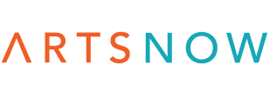
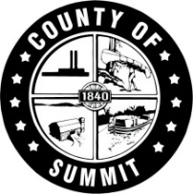
NEWS RELEASE

FOR IMMEDIATE RELEASE

Date: October 8, 2019

Contacts:
Greta Johnson Nicole Mullet
Assistant Chief of Staff ArtsNow
Office of Executive Shapiro 330-752-2815
330-643-2656 nicole@ArtsNow.org
gjohnson@summitoh.net

October named National Arts and Humanities Month in Summit County
SUMMIT COUNTY, OHIO— Yesterday, County Executive Ilene Shapiro and County Council declared October Arts and Humanities Month in Summit County in honor of the efforts of artists, historians, teachers, and cultural groups working to make the arts and humanities a part of everyone’s life. ArtsNow and Summit County join thousands of arts, culture and humanities organizations and communities across the nation in celebrating National Arts and Humanities Month.

“Summit County has a rich history of celebrating the importance of the arts and humanities in our communities. Further, we know the creative economy generates millions in wages and income, and supports thousands of jobs,” said Executive Shapiro. “It is with great confidence in the excellence of our cultural sector and a deep appreciation of the individuals working in this space every day that we declare October National Arts and Humanities Month in Summit County.”

In honor of National Arts and Humanities Month, residents are encouraged to participate in a national social media campaign with Americans for the Arts and ArtsNow. The campaign, entitled, “Show Your Arts 2019”, will once again feature a unique theme every day in October, with new personal prompts like “Art that Changed Me,” “On My Bookshelf” and “I Made This!” to inspire residents to express themselves. Residents are encouraged to join in using #ShowYourArt2019 on social media and tag ArtsNow and Americans for the Arts to engage on a regional and national platform.

“National Arts and Humanities Month gives us a chance to celebrate the often overlooked economic, educational, and civic engagement values that the arts impart in our daily lives,” said Robert L. Lynch, president and CEO of Americans for the Arts and national coordinator of Arts and Humanities Month. “The arts allow us to explore ideas, express emotions, and better appreciate cultures from around the world, and I hope that everyone will take part to celebrate and recognize the creative and cultural value of the arts and humanities in our communities.”

More information about National Arts and Humanities Month is available at www.AmericansForTheArts.org/nahm. Engage with ArtsNow on social media using @ArtsNow_Ohio (Twitter), @artsnowoh (Instagram) and @SummitArtsNow (Facebook).

About ArtsNow
ArtsNow works to leverage the arts, culture, and environmental sector in Summit County to support and strengthen the region’s economic and social vibrancy. To learn more about ArtsNow, visit www.ArtsNow.org.
###

