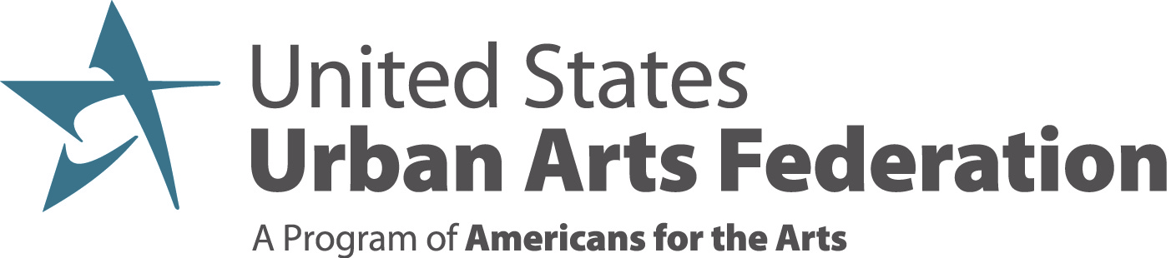

2020 United States Urban Arts Federation Summer Meeting
Ring Central – July 22, 2020; 3:00p-5:00p

KNOW BEFORE YOU ARRIVE

Primary contact: Ruby Lopez Harper, cell: 614.806.5880

Technology?
We will be using Ring Central for our video conference line. Please make sure to click the link provided in the Outlook invitation prior to the call to ensure your browser or app download is working properly.

Do I need to prepare anything?
- We would love to continue our land acknowledgement practice. We ask that you prepare your introduction for sharing in the chatbox when prompted as follows:

Full Name, Organization, City/State, Pronouns, Land acknowledgment
(Ruby Lopez Harper, Americans for the Arts, Silver Spring, MD, She/Her/hers, I am calling from the lands of the Nacotchtank tribe. To learn more about the native tribes of the DC/Metro Area: www.ala.org/aboutala/indigenous-tribes-washington-dc)

We will capture these as part of the meeting record and distribute with the debrief materials and call recording.

- Confirm your breakout conversation choices by July 21, 5:00p ET

Respond here >>> https://doodle.com/poll/2r7k8vyucyatp9rt

WEDNESDAY, July 22, 2020

Meeting Link: https://meetings.ringcentral.com/j/1496995694

3:00p Welcome/introductions (Jody)

Rules of engagement (Ruby)

Review agenda (Andy)

AFTA Updates (Bob/Mara)

CARES Funding Updates (Narric)

Hanley Award presentation (Bob)

3:45p Break: 10 minutes to refresh, regroup, check email, bio break, etc.
If you choose to stay on the line, we will be hosting a 10 minute movement break

3:55p Setup for the breakouts

4:00p Breakouts

- Grantmaking and resource distribution/allocation in the new normal (Jody)
As budgets are affected by revenue loss and cuts, how are LAAs re-aligning, re-imagining and re-engineering resources (grants, training, services, etc.) to maximize impact? How do we hear what communities need beyond the money? What relationships can we leverage in support of the community to open access to more resources?

- Casemaking/Value proposition of the role of the LAA in recovery and rebuilding (Jonathon)
How do we preserve and protect the agency during this transition? How do we convey the value of the work LAAs do in community? How do we make visible the work that community may not be aware of? What relationships should we be centering to ensure understanding? What influence do we have with other arts funders?

- The role of the LAA in addressing civil unrest and advancing social justice (Patrick)
What role do LAAs play when leading or supporting equity efforts and understanding which role to play and when? Is there something we as LAAs can do that would help to fill voids that develop from defunding police in localities? How do we use our resources to create safe spaces for dialogue? What are the boundaries of what we can and can’t do as LAA leaders?

4:45p Next steps, path ahead (Ruby)

5:00p OPTIONAL HAPPY HOUR

Meeting Link: https://meetings.ringcentral.com/j/1497223558;

Grab your favorite beverage and join your colleagues for an informal gathering

