THE MAYORS ARTS PROGRAM
Featuring the 2018 Public Leadership in the Arts Awards
Honoring
The Honorable Javier M. Gonzales, Mayor of Santa Fe, New Mexico
The Honorable Mike Rawlings, Mayor of Dallas, Texas
The Honorable Larry Hogan, Governor of Maryland
Michael Cerveris, Artist
Featured Guest Speaker
The Honorable Karen Pence, Second Lady of the United States
Special Art Presentation
Burning Man
Friday, January 26, 2018
Washington, DC
Presented by
Americans for the Arts and
The United States Conference of Mayors

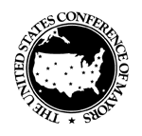
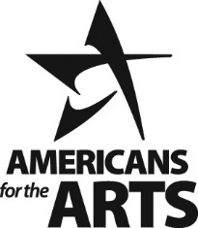

Mayor Javier M. Gonzales
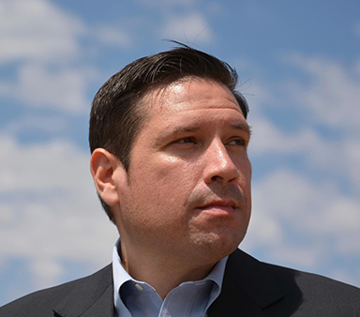

Within 60 days of taking office, Mayor Gonzales convened over 100 community leaders to frame his administration’s work in arts and culture. Throughout his term, the focus has been on protecting, preserving and growing the Santa Fe brand; fostering broad collaboration; ensuring the arts were present in the lives of young people; and securing inclusive access to cultural institutions for the Santa Fe community.
Mayor Gonzales called for Santa Fe’s first cultural planning process. More than a plan, it was a civic process for developing a more equitable community through culture. Nearly 2,000 people participated in assemblies, conversations, interviews and surveys. The picture that emerged was of a community facing significant challenges. Mayor Gonzales stood firm, insisting that Santa Fe’s creative talent and deep-rooted culture hold transformative power. The resulting document, Culture Connects Santa Fe: A Cultural Cartography, recognizes that art and culture have the potential to connect Santa Fe. At the heart of Culture Connects are notions about protecting our cultural heritage, traditions and diversity while understanding that growth comes from evolving our thoughts and actions. Mayor Gonzales shepherded the plan through city council with unanimous approval. He championed the creation of a full-time position to support the work, along with $125,000 in additional first year funding for its initiatives.
Under Mayor Gonzales, annual local government support for the arts has exceeded $1.5 million. An impressive amount for a community of 83,875. Highlights of this support over the past four years include approximately $900,000 in direct arts grants to nonprofits yearly; $300,000 in collaborative arts grants; and over $200,000 in small public art acquisitions and $150,000 in infrastructure-related public art.
Santa Fe Mayor Javier M. Gonzales receives the 2018 Americans for the Arts and The United States Conference of Mayors National Award for Local Arts Leadership for cities with a population under 100,000.

Mayor Mike Rawlings
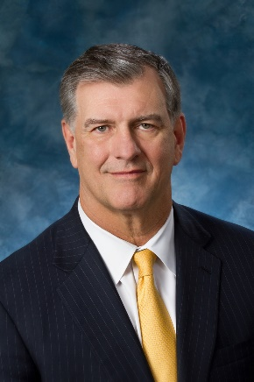
Dallas is a city with a dynamic and growing cultural ecosystem. The Dallas Arts District, with its iconic visual and performing arts venues that mayors experienced firsthand at the 2014 United States Conference of Mayors Annual Meeting, draws significant tourism downtown, spurs development, boosts property values and generates $395 million a year in economic impact. A major reason this ecosystem remains so vibrant is Mayor Mike Rawlings. From the start of his first term, he wanted to be known as the “Arts Mayor.”

Since taking office in 2011, Mayor Rawlings has never shied away from taking the lead and using his bully pulpit to talk about the importance and impact of the arts on the city’s economy and quality of life. At the start of his first term, Mayor Rawlings started Dallas Arts Week to shine a spotlight on the city’s arts organizations and work. It has proven so successful that Mayor Rawlings expanded the week-long celebration to the full month of April, showcasing 55 arts groups and 156 events, including his Creative Conversations panels discussing tough issues for the arts.

Mayor Rawlings also supported the effort to create a new cultural policy for the city–the first since 2002. He supported city staff efforts to add funding to the Dallas Office of Cultural Affairs, including the first-time use of the city’s hotel occupancy tax toward the arts. Mayor Rawlings also supported efforts to create another special marketing fund within the new Tourism Public Improvement District, which now provides almost $1.2 million annually in marketing grants, mostly to arts and cultural programs that attract tourists to Dallas.

Dallas Mayor Mike Rawlings receives the 2018 Americans for the Arts and The United States Conference of Mayors National Award for Local Arts Leadership for cities with a population of 100,000 or more.

Governor LArry Hogan

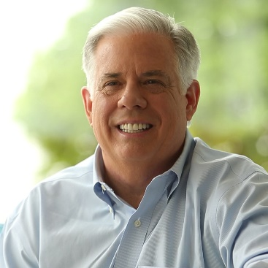

Maryland is proud to be ranked fourth in the nation in per capita spending on the arts. Maryland’s arts sector boasts a $1 billion industry, consisting of hundreds of arts organizations and thousands of artists from the Eastern Shore to the far reaches of Western Maryland Appalachia.
Since taking office in 2014, Governor Hogan has been an avid supporter of the arts and helped ensure its continued success by supporting strong investments for the Maryland State Arts Council. During Governor Hogan’s term, the state arts council has seen an almost 50 percent increase in state funding for the arts and now has an annual appropriation that stands comfortably over $20 million, supporting hundreds of Maryland artists and arts organizations.
Additionally, the Governor and First Lady of Maryland Yumi Hogan support the arts to improve the quality of life in Maryland. Examples include launching an art therapy program at the University of Maryland Medical Center and hosting a biannual artwork exhibit in the Maryland House of Delegates, which features K-12 student artwork from every county in Maryland.

Maryland Governor Larry Hogan receives the 2018 Americans for the Arts and The United States Conference of Mayors National Award for State Arts Leadership.

Michael Cerveris
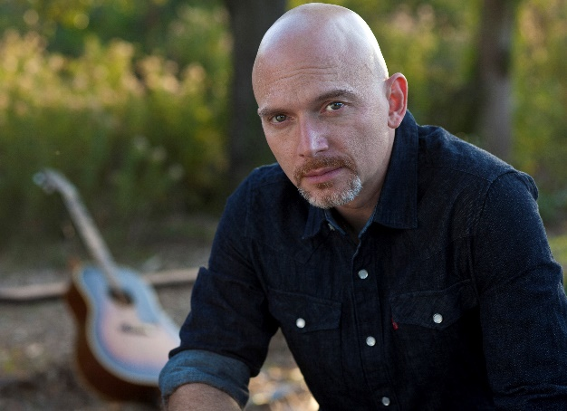
Michael Cerveris is a two-time Tony Award® winning stage and screen actor and musician, as well as a dedicated advocate for the arts, education and numerous humanitarian causes. He has performed in many stage musicals and plays, including several Stephen Sondheim musicals: Assassins, Sweeney Todd: The Demon Barber of Fleet Street, Road Show, and Passion. In 2004, Michael won the Tony Award® as Best Featured Actor in a Musical for Assassins as John Wilkes Booth. In 2015, he won his second Tony Award® as Best Actor in a Musical for Fun Home as Bruce Bechdel.
Michael devotes much of his time outside work to many social causes close to his heart. For each of the last 13 years, he has participated in the Multiple Sclerosis Society’s Walk, raising over $160,000 to date. He is an active and longtime supporter of Broadway Cares/Equity Fights AIDS and the Actors Fund. Michael performs often in support of humanitarian causes, including From Broadway With Love: A Benefit for Sandy Hook and the What The World Needs Now recording and concert for victims of the Pulse Nightclub shooting. He has organized several other benefit concerts over the years, including Take Me Home – a concert for West Virginia, which raised funds and awareness for relief efforts following the floods of 2016.
Michael appears in Steven Soderberg’s Mosaic on HBO, and has created such iconic roles as September, The Observer over five seasons in JJ Abrams’ Fringe, and fan favorite Professor Pyg on FOX’s Gotham, along with Ramses IV in Amazon’s The Tick, State’s Attorney James Castro on CBS’ The Good Wife and three seasons as Marvin Frey on HBO’s Treme.
He helped organize and perform at the grand reopening of New Orleans’ majestic Saenger Theater, appearing with Kristin Chenoweth and Mayor Mitch Landrieu and receiving the Mayor’s Key to the City for his contributions.
Michael Cerveris receives the 2018 Americans for the Arts and The United States Conference of Mayors Citizen Artist Award.
Americans for the Arts is the nation’s leading nonprofit organization for advancing the arts in America. With more than 50 years of service, it is dedicated to representing and serving local communities and creating opportunities for every American to participate in and appreciate all forms of the arts. Additional information is available at www.AmericansForTheArts.org.
Founded in 1933, The United States Conference of Mayors is the official nonpartisan organization of cities with populations of 30,000 or more. The primary roles of the Conference of Mayors are to promote the development of effective national urban/suburban policy; strengthen federal-city relations; ensure that federal policy meets urban needs; provide mayors with leadership and management tools and create a forum in which mayors can share ideas and information. Find more information at www.usmayors.org.

